Distance Formula:
Slide 1: Slide 2:

______________________ _______________________
Slide 3: Slide 4:
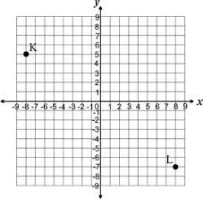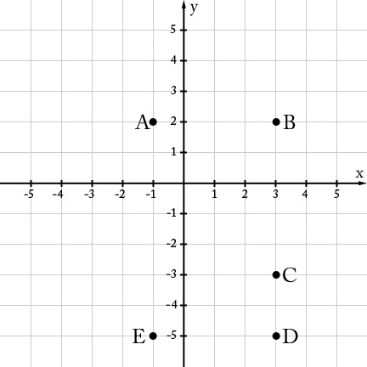

KL: _________________ AB: ____________________________

BC: ____________________________

CD: ____________________________

DE: ____________________________

EA: ____________________________

