Anna has let out 50 meters of kite string when she observes that her kite is directly above Emily. If Anna is 35 meters from Emily how high is the kite?

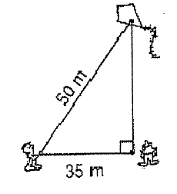

X = _________

The diagram at the right shows how a post was broken.
What was the original height of the post?
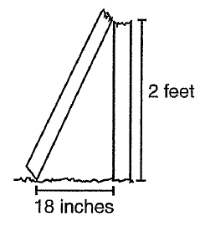
24 inches

X = __________

Segment Addition Postulate:

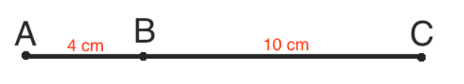
Complete:
___________ + ___________ = ___________
So
___________ + ___________ = ___________

Write out the segment addition postulate and find the length of the missing line segment.
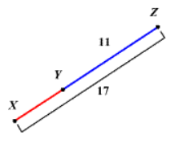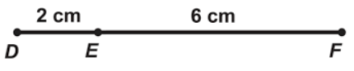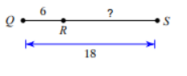
_____ + _____ = _____ _____ +_____ = ______ _____ +_____ = ____

XY = ____ DF = ____ RS = ______

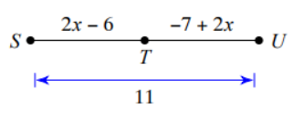
Set up an equation and solve for x.
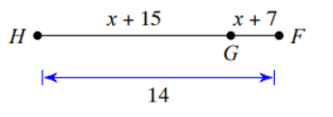
Set up an equation, solve for x and the indicated line segment
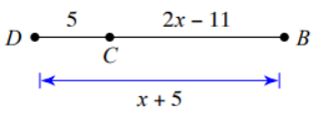 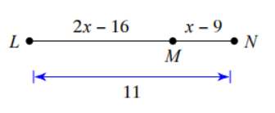 $x=___________$ $x=___________$
$BD=___________$ $MN=__________$

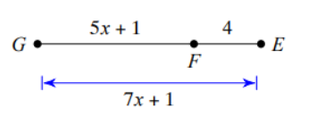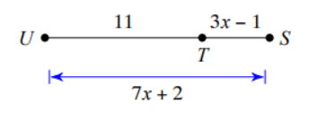
X = _____ X = _____
GF = ____ FE = ____ GE = ____ UT = ____ TS = _____ US = ____

