Name: _________________________________________________________________________ Date: _________ Hour: _____
History of the Earth Timeline
Directions: Use the timeline of Earth’s geologic history below to answer questions 1-10. Your answers must be in complete sentences to receive credit!
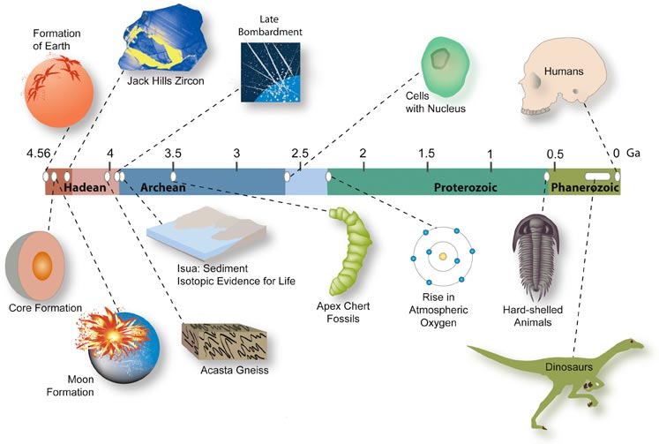

1. How many billion years ago did Earth form? 2. What happened approximately 2.6 billion years ago?

3. Did the formation of Earth’s core occur before or 4. How many billions of years ago did a rise in atmospheric
after the formation of the moon? oxygen occur?

5. What geological event occurred 0.6 billion years ago? 6. What events occurred between 3 and 4 billion years ago?

7. How many billion years ago did the dinosaurs exist? 8. Does this timeline represent all of Earth’s geologic history?
Why or why not? Explain.

“History of the Earth” Create Your Own Timeline
Use the equation below to figure out the history of the Earth on a meter stick.
1 meter = _____ cm Divide : Year x 100 = _____ cm
Year | Event | Calculation | Result (cm to mark)
5 billion | Earth was formed with the other planets. | 5/5 x 100 = 100 | 100 cm
3.7 billion | Earth’s crust became solid | 3.7/5 x 100 = 74 | 74 cm
3.5 billion | Bacteria appears | 3.5/5 x 100 = 70 | 70 cm
3.25 billion | Photosynthesis begins in ocean
2.4 billion | Oceans have a large amount of oxygen
1.9 billion | Sea sponges in oceans appear
.65 billion | First multi-cellular organisms appear
.5 billion | First land plants appear
.44 billion | Spiders, scorpions, insects, complex plants appear
.41 billion | First fish appear
.35 billion | Amphibians appear, trees spread, first forest
.3 billion | Winged insects, cockroaches appear
.25 billion | Mass extinction- 99% of all life
.245 billion | Age of the Dinosaurs begins
.15 billion | Supercontinent Pangaea breaks up
.14 billion | Sharks, bees, butterflies, flowering plants appear
.065 billion | Age of Dinosaurs ends, pigs cats, bears, whales appear
.001 billion | First Humans appear

