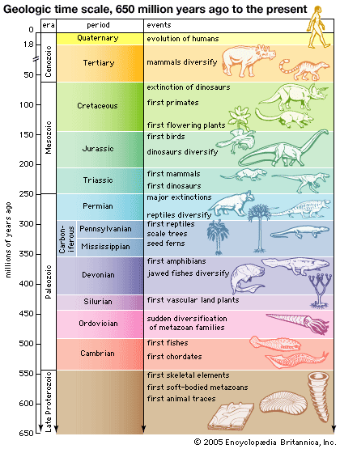

Name: _____________________
Date: _________________
Period: _________
Geologic Time Scale Worksheet
- Tell which era the following events occurred in:
Precambrian
Paleozoic
Mesozoic
Cenozoic

Event/ Clue | Era
Includes the present time we live in
The longest era in Earth’s history
Angiosperms (flowering plants) first appeared
Mammals were dominant and began to diversify
When life first began
Only microorganisms and soft-bodied invertebrates like sponges and jellyfish lived
Life began on land
Dinosaurs first appeared
Reptiles first appeared
Birds first appeared
Includes the Jurassic and Triassic periods
Man evolved
Contains the largest number of different periods
Dinosaurs were dominant
Major extinction of aquatic and terrestrial organisms
Dinosaurs became extinct
Aquatic life diversifies
Primates first appeared

- Put the following in order from longest amount of time to shortest: period, era, epoch

- Put the following in the order which they occurred: Cenozoic, Paleozoic, Mesozoic, Precambrian

