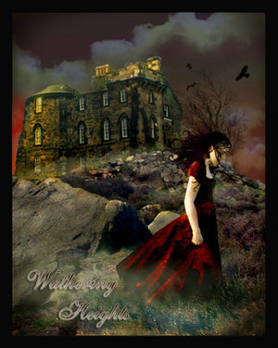#1. *Wuthering Heights* by Emily Bronte:1847

The intense horror of nightmare came over me; I tried to draw back my arm, but, the hand clung to it, and a most melancholy voice sobbed,

“Let me in – let me in!”

“Who are you?” I asked, struggling, meanwhile, to disengage myself.

“Catherine Linton,” it replied, shiveringly (why did I think of *Linton*? I had read *Earnshaw* twenty times for Linton). “I’m come home, I’d lost my way on the moor!”

As it spoke, I discerned, obscurely, a child’s face looking through the window – Terror made me cruel; and, finding it useless to attempt shaking the creature off, I pulled its wrist on to the broken pane, and rubbed it to and fro till the blood ran down and soaked the bed-clothes: still it wailed, “Let me in!” and maintained its tenacious grip, almost maddening me with fear.

Station #1

**Q1) What is particularly shocking about the narrator’s actions in this passage?**

**Q2) We discover that this ‘child’ is in fact a dream or a ghost. Why do you suppose it appeared to the narrator?**

**Q3) What elements of Gothic Literature can you identify in this extract?**

Stations 2

**Q1) Look at the first long sentence, lines 1-5. What does this long sentence tell us about the narrator’s state of mind?**

**Q2) What is unusual about the narration in line 14? What does this tell us about the story?**

**Q3) In your own words, explain the narrator’s actions in lines 13-17.**

**Q4) The narrator’s husband is among the intruders! How would she feel about this?**

**Q5) What do the intruders seem to be up to?**

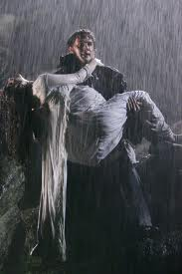*The Grey Woman* by Elizabeth Gaskell 1861

1 In mortal terror of people forcing an entrance at such an hour, and in such

2 a manner as to leave no doubt of their purpose, I would have turned to fly

3 when I first heard the noise, only that I feared by any quick motion to catch

4 their attention, as I also ran the danger of doing by opening the door, which

5 was all but closed, and to whose handlings I was unaccustomed. Again,

6 quick as lightning, I bethought me of the hiding-place between the locked

7 door to my husband’s dressing-room and the portiere which covered it; but

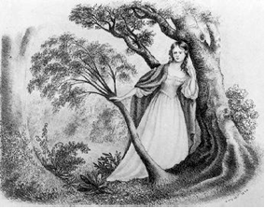8 I gave that up, I felt as if I could not reach it without screaming or fainting.

9 So I sank down softly, and crept under the table, hidden, as I hoped, by the

10 great, deep, table-cover, with its heavy fringe. I had not recovered my

11 swooning senses fully, was trying to reassure myself as to my being in a

12 place of comparative safety, for, above all things, I dreaded the betrayal of

13 fainting, and struggled hard for such courage as I might attain by deadening

14 myself to the danger I was in by inflicting intense pain on myself. You have

15 often asked me for the reason of that mark on my hand; it was where, in

16 my agony, I bit out a piece of flesh with my relentless teeth, thankful for

17 the pain, which helped to numb my terror. I say, I was but just concealed

18 when I heard the window lifted, and one after another stepped over the sill,

19 and stood by me so close that I could have touched their feet. Then they

20 laughed and whispered; my brain swam so that I could not tell the meaning

21 of their words, but I heard my husband’s laughter among the rest – low,

22 hissing, scornful – as he kicked something heavy that they had dragged in

23 over the floor, and which lay near me; so near, that my husband’s kick, in

24 touching it, touched me too. I don’t know why – I can’t tell how – but

25 some feeling, and not curiosity, prompted me to put out my hand, ever so

26 softly, ever so little, and feel in the darkness for what lay spurned beside

27 me. I stole my groping palm upon the clenched and chilly hand of a corpse!

Station 2

Station 3

**Q1) How does the writer, Mary Shelley create a gloomy and eerie setting in the first paragraph?**

**Q2) Look carefully at the words used to describe Frankenstein’s creation. What words does Shelley use to show that it is far from being human?**

**Q3) Why does Frankenstein refer to this event as a “catastrophe”?**

**Q4) In your own words, explain what is frightening or unnatural about the creature’s appearance.**

Station 3

*Frankenstein* by Mary Shelley 1817

It was on a dreary night of November, that I beheld the accomplishment of my toils. With an anxiety that almost amounted to agony, I collected the instruments of life around me,that I might infuse a spark of being into the lifeless thing that lay at my feet. It was already one in the morning; the rain pattered dismally against the panes, and my candle was nearly burnt out, when, by the glimmer of the half-extinguished light, I saw the dull yellow eye of the creature open; it breathed hard, and a convulsive motion agitated its limbs.

How can I describe my emotions at this catastrophe, or how delineate the wretch whom with such infinite pains and care I had endeavoured to form? His limbs were in proportion, and I had selected his features as beautiful. Beautiful! – Great God! His yellow skin scarcely covered the work of muscles and arteries beneath; his hair was of a lustrous black, and flowing; his teeth of pearly whiteness; but these luxuriances only formed a more horrid contrast with his watery eyes, that seemed almost of the same colour as the dun-white sockets in which they were set, his shrivelled complexion and straight black lips.

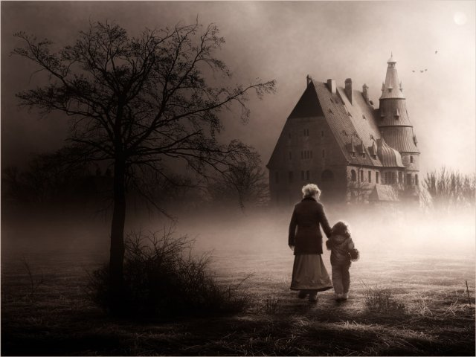

Station 4

Q1) What mood do you see in this image? Explain how it makes you feel?

Q2) Choose five words to describe the setting?

Q3) Briefly imagine what this story could be about? Write 2 to 3 sentences describing what could be happening.

Station 5

Q1) What can you tell me about the setting? Use your notes and evidence from the passage to help you identify and explain.

Q2) Quickly write a description of the man you saw emerge from the door. What does he look like? Describe the features of his face and his general appearance, and then write a sentence or two about what the man does when he sees you.

Q3) How does the setting and the description you created effect the mood of this passage? Explain.

Station 5: Dr. Jekyll and Mr. Hyde

You are out for a Sunday walk. It is 1865, and you are in a busy quarter of London in a drab and dingy part of town. But you walk down a brightly decorated side street that is lined with shops on both sides. The storefronts are very attractive—they stand along the street with an air of invitation, like rows of smiling saleswomen. Even on Sunday, when it veils its more florid charms and lies comparatively empty of passage, the street shines out in contrast to its dingy neighborhood, like a fire in a forest; and with its freshly painted shutters, well-polished brasses, and general cleanliness and gaiety of note, instantly catches and pleases your eye. Two doors from one corner, the line of shops is broken by the entry of a courtyard; and just at that point, a certain sinister block of building thrusts forward its gable on the street. It is two stories high; shows no window, nothing but a door on the lower story and a blind forehead of discolored wall on the upper story; and bears in every feature the marks of prolonged and sordid negligence. The door, which is equipped with neither bell nor knocker, is blistered and stained. Tramps have slouched into the recess and have struck matches on the panel. You stare at the sinister looking door and wonder who could be living behind it. A cold chill and feeling of dread creeps upon you. Then, before your eyes, the door slowly opens and a man emerges from it. He gives you a long and menacing look. In spite of your fear, you look closely at the man. How does the man look? See his eyes, his mouth, his face, and his hair. How is he standing? What is he wearing? What does he do?

Stations 6

Q1)Why does the author begin by describing the Dr.? What kind of significance can this play in this gothic novel?

Q2) How does the author describe the setting?

Q3) By describing all of the characters right away you can hear the authors tone? Explain what you think the authors tone is? (tone: Authors attitude toward subject, idea, etc).

Station 6

The Body Snatchers by [**Robert Louis Stevenson**](http://www.eastoftheweb.com/cgi-bin/read_db.pl?search_field=author_id&search_for=RobertLouisStevenson&order_by=author_last,title&page=1)

Every night in the year, four of us sat in the small parlour of the George at Debenham - the undertaker, and the landlord, and Fettes, and myself. Sometimes there would be more; but blow high, blow low, come rain or snow or frost, we four would be each planted in his own particular arm-chair. Fettes was an old drunken Scotchman, a man of education obviously, and a man of some property, since he lived in idleness. He had come to Debenham years ago, while still young, and by a mere continuance of living had grown to be an adopted townsman. His blue camlet cloak was a local antiquity, like the church-spire. His place in the parlour at the George, his absence from church, his old, crapulous, disreputable vices, were all things of course in Debenham. He had some vague Radical opinions and some fleeting infidelities, which he would now and again set forth and emphasise with tottering slaps upon the table. He drank rum - five glasses regularly every evening; and for the greater portion of his nightly visit to the George sat, with his glass in his right hand, in a state of melancholy alcoholic saturation. We called him the Doctor, for he was supposed to have some special knowledge of medicine, and had been known, upon a pinch, to set a fracture or reduce a dislocation; but beyond these slight particulars, we had no knowledge of his character and antecedents.

Station 7

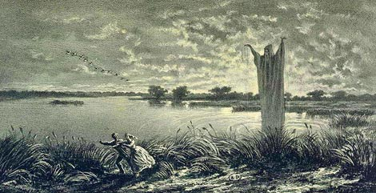

Station 7

Q1) What mood do you see in this image? Explain how it makes you feel?

Q2) Choose five words to describe the setting?

Q3) Briefly imagine what this story could be about? Write 2 to 3 sentences describing what could be happening.

Station 8

Q1) What mood do you see in this image? Explain how it makes you feel?

Q2) Choose five words to describe the setting?

Q3) Briefly imagine what this story could be about? Write 2 to 3 sentences describing what could be happening.

Station 9 Masque of the Red Death by Edgar Allen Poe

The Red Death had long been feeding on the country.

No sickness had ever been so deadly — so great a killer — or so fearful to see. Blood was its mark — the redness and the **horror** of blood.

There were sharp pains, and a sudden feeling that the mind was rushing in circles inside the head. Then there was bleeding through the skin, though it was not cut or broken — and then, death!

The bright red spots upon the body and especially upon the face of the sick man made other men turn away from him, afraid to try to help. And the sickness lasted, from beginning to the end, no more than half an hour.

But Prospero, the ruler of that land, was happy and strong and wise. When half the people of his land had died, he called to him a thousand healthy, happy friends, and with them went far away to live in one of his **palaces**.

This was a large and beautiful stone building he had planned himself. A strong, high wall circled it. This wall had gates of iron. The gentlemen, after they had entered, brought fire to heat the iron of the gate to make them close so firmly that nobody could open them. Here they could forget the sickness, the Red Death. They would leave the outside world to care for itself.

Prospero had supplied everything they needed for pleasure. There was music. There was dancing. There was beauty. There was food to eat and **wine** to drink. All these were within the wall, and within the wall they would be safe. Outside the wall walked the Red Death.

It was near the end of their fifth month there that Prospero asked his friends to all to come together for a dancing party, a **masquerade**. Everyone was asked to come dressed in fine clothes and with his eyes, or perhaps his whole face, covered by a cloth **mask**.

Station 9

Q1) What words can you identify that would tell you a specific time period?

Q2) Examine parts of this passage pulling out 3 examples of gothic literary terms. Explain what they do for and create in the story.

Q3) What is the conflict in this passage? Explain how you identified it? Choose 1 piece of textual evidence to support your explanation.

Station 10

Q1) What mood do you see in this image? Explain how it makes you feel?

Q2) Choose five words to describe the setting?

Q3) Briefly imagine what this story could be about? Write 2 to 3 sentences describing what could be happening.

Station 10