The war had left the countries involved pretty broke. By the late 1920s, the world economy had slowed down. Wages were down, sales were down, and the market for farm goods wasn’t doing well.
Causes of the Great Depression in the US
Britain and France had a huge debt to pay to the US. They wanted Germany to pay the US through reparations Germany owed Britain and France. However, Germany was out of cash too, and could only pay reparations by borrowing money from the US to give to Britain and France to give to the US. This cycle of borrowing and lending was a problem.
Bank Run- Many Americans ran to get money out of their banks when the stock market crashed. The banks told them sorry, but they didn’t have the money. President Franklin Roosevelt made laws to ensure protection of citizens’ money in banks after that.
WWI left the US in much better shape than it did Europe. The government had needed war supplies, and this created jobs. During the 1920s, Americans started investing in the stock market. They began making purchases on credit. However, the export market was down because Europeans didn’t have money for American goods. When Europeans had trouble paying towards their debt, American banks crumbled. On October 29, 1929, the American stock market crashed, and severe unemployment followed. This economic crisis was the Great Depression.
Roosevelt’s New Deal
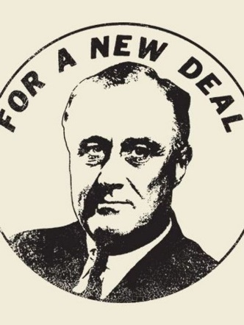
Within the first hundred days of his presidency in 1933, US president Franklin D. Roosevelt (FDR) created a program called the NEW DEAL to combat the economic downturn, including:
- The Federal Emergency Relief Administration (FERA): helped the unemployed
- The agricultural adjustment administration (AAA): raised food prices to help farmers
- The public works administration (PWA): sponsored public works projects and created new jobs (building bridges, post offices, airports, and roads)
In 1935, a second New Deal established a public works program known as the Works Progress Administration (WPA), which replaced FERA and created over three million jobs. The second new deal also created unemployment insurance and social security. FDR also improved the banking system and expanded rights for labor unions. Impressive – but three years later nearly eleven million Americans remained unemployed.
Depression around the World
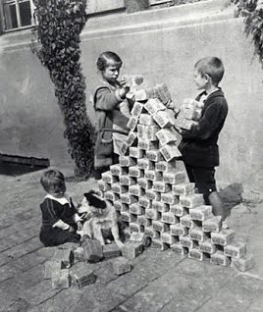
To get back on its feet, Great Britain used traditionally conservative policies of balancing budgets and imposing protective tariffs. They also used economic retrenchment policies, which basically meant they cut down on unnecessary expenses. Other European countries were less fortunate in facing recovery. Desperate countries turned to leaders who promised to help but who became despots- a dictator. In Germany, Adolf Hitler came to power as leader of the National Socialist German Workers’ Party, or the NAZIs. Hitler called for a crusade against communists and Jews, whom he blamed for Germany’s defeat in WWI. The Germans knew one way to get out of debt was to attack the countries they owed money to. WWII was soon to come.
This image shows German children playing with stacks of Germany money called the Deutsch Mark. This is a result of hyperinflation- money became almost worthless because you needed so much of it purchase necessities. People even burned money to warm their homes.

Questions: Respond in complete sentences on lined paper.
- What was the major factor contributing to the decline of the world economy?
- What happened to American banks when European countries were unable to pay off their debts?
- What program did FDR create to combat the Great Depression?
- Explain the details of FDR’s program.
- How did Great Britain attempt to combat the Great Depression?
- What major historical figure came to power in Germany during this time period?
- What groups of people did this figure blame for many social and economic problems during this time?

