Name: _________________________ Date: ________
Constructions Note Sheet
- Constructing a parallel through a point
After doing this | Your work should look like this
Start with a line PQ and a point R off the line.
1. Draw a  __________________  through R and across the line PQ at an angle, forming the point J where it intersects the line PQ. The exact angle is not important. | 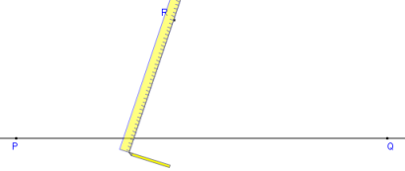
2. With the compasses' width set to about half the distance between R and J, place the point on J, and draw an arc across both lines. | 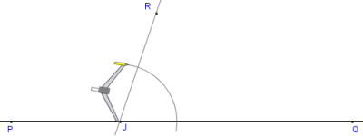
3. ___________ adjusting the compasses' width, move the compasses to _____ and draw a ________________ to the one in step 2. | 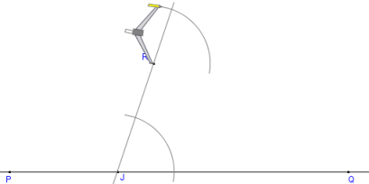
4. Set compasses' width to the distance where the  ________________ crosses the ________________. | 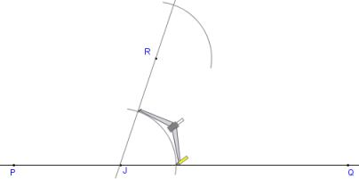
5. Move the compasses to where the upper arc _________________  _________________  and draw an arc across the upper arc, forming point S. | 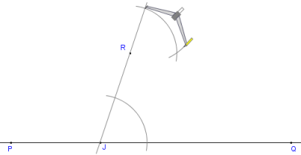
6. Draw a straight line through points ______ and _______. | 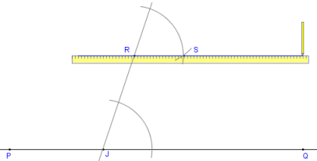
Done. The line RS is ________________ to the line PQ | 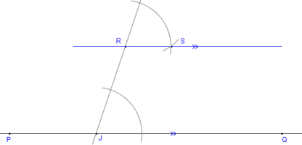

- Bisecting an angle

After doing this | Your work should look like this
Start with angle PQR that we will bisect.
1. Place the compasses' point on the angle's _____________ Q.
2. Adjust the compasses to a medium wide setting. The exact width is not important.
3. Without changing the compasses' width, _________________ across each leg of the angle.
4. The compasses' width can be changed here if desired. Recommended: leave it the same.
5. Place the compasses on the point where ____________________ and draw an arc in the interior of the angle.
6. _________________ the compasses setting repeat for the other leg so that the two arcs cross.
7. Using a straightedge or ruler, draw a line from the vertex to the point where the arcs cross
Done. This is the _____________ of the angle ∠PQR.

- Constructing the perpendicular bisector of a line segment

After doing this | Your work should look like this
Start with a line segment PQ.
1. Place the compasses on one end of the line segment.
2. Set the compasses' width to _____________________________________________  The actual width does not matter. | 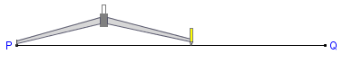
3. Without changing the compasses' width, draw an arc ______________________________ the line.
4. Again without changing the compasses' width, place the compasses' point ______________________________ of the line. Draw an arc above and below the line so that the arcs cross the first two.
5. Using a straightedge, draw a line between the points where the arcs ______________. | 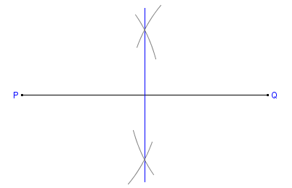
6. Done. This line is _____________ to the first line and bisects it (cuts it at the exact _______________of the line). | 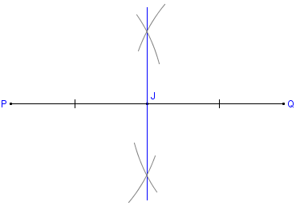
- Constructing the altitude of an acute triangle
After doing this | Your work should look like this
We start with an acute triangle PQR.
See also the version for obtuse triangles.
1. Choose one side of the triangle and extend it in both directions.
This is done because the side may not be long enough to perform the steps that follow.
2. Set the compass on the opposite vertex (here R) and set the width to ___________________

PQ.
3. Make two arcs across PQ, creating the points A and B.
4. From A and B, make two arcs that ________, creating point C. Make sure both arcs are drawn with the ____________
___________________.
5. Draw a line through ______ and ______. Label the point S where it crosses PQ.
Done The segment RS is an ______________ of the triangle PQR.

