Name _______________________________________________________________ Period ________________________________

Histograms and Dot Plots Worksheet

Directions: Create a histogram for each set of data. For the first problem, the graph is set up for you. For the second problem, you will need to determine the best way to number the axes. Do not forget to include a title as well.

1. Chocolate candies per bag of trail mix:

50 42 100 45 68 32 100

67 61 31 75 39 62 64

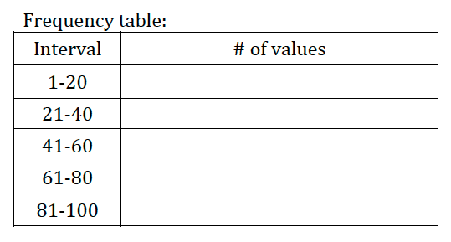
49 55 51 33 99 96 64

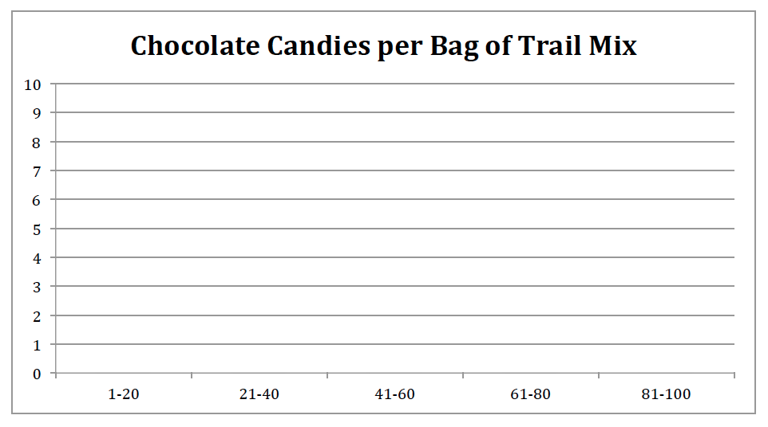

2. Test scores, out of 100 points
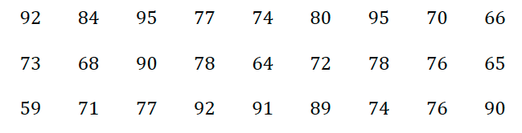
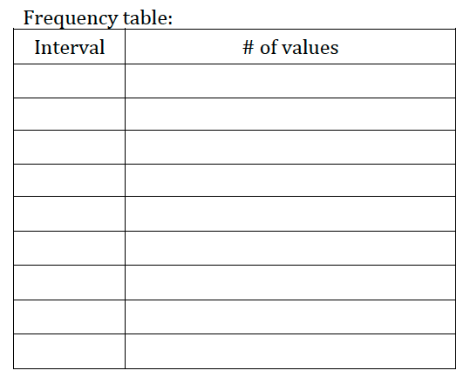

Directions: Answer the following questions based on each of the dot plots.

1. The dot plot below shows the number of students in each of the teacher’s class.
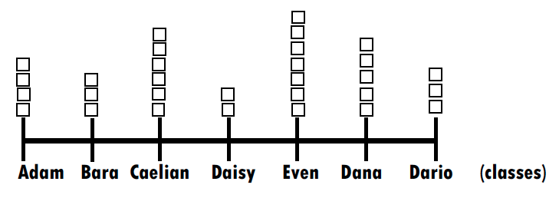

- How many total students are there in all classes?

- Which class has the least number of students?

- Which class has the most number of students?

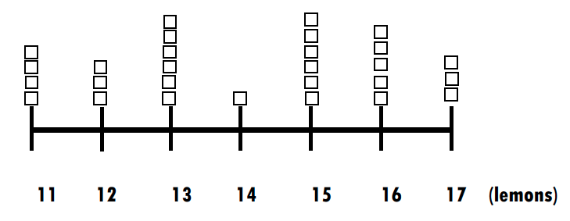
2. The dot plot shows the number of lemons each person has.

- How many total individuals are represented in the dot plot?

- What is the total number of lemons that the individuals have?

3. The following data shows the amount of chocolate Mrs. Latimer ate over the last 30 days. Create a dot plot to show how much chocolate she ate.

3, 5, 9, 2, 4, 5, 3, 8, 7, 4, 2, 9, 7, 1, 2, 2, 5, 7, 12, 6, 3, 7, 9, 2, 1, 7, 4, 3, 9, 11

