Human Activities and Biodiversity—Notes Organizer Name:___________________
Background Information
- Today, as in the past, people have a huge impact on biodiversity. _______________________________________________________________________________________________________________________________________________.

- Scientists ________________________________________________________________ _______________________________________________________________________.

- Recent Measurements ____________________________________________________ _______________________________________________________________________.

- Some scientists think such evidence means the earth ____________________________ _______________________________________________________________________.

- Since Earth’s biodiversity provides so many valuable goods and services to humans, and biodiversity is important for the health and well-being of ecosystems, these extinctions will likely have adverse consequences for humans’ social and economic well-being.
- Biodiversity_____________________________________________________________ ______________________________________________________________________.
Expected vs. Observed Extinctions
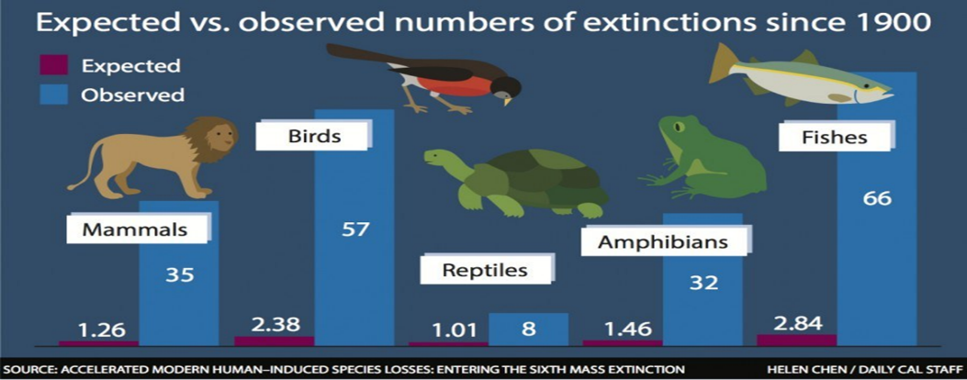
Prediction: What could be the explanation for why there have been more extinctions of fish species than other organisms?

- Biodiversity ______________________________________________________________ ________________________________________________________________________________________________________________________________________________

- Ecosystem Diversity _______________________________________________________ ________________________________________________________________________

- Genetic Diversity _________________________________________________________ ________________________________________________________________________

- Species Diversity _________________________________________________________ ________________________________________________________________________

- Taxa ___________________________________________________________________ ________________________________________________________________________

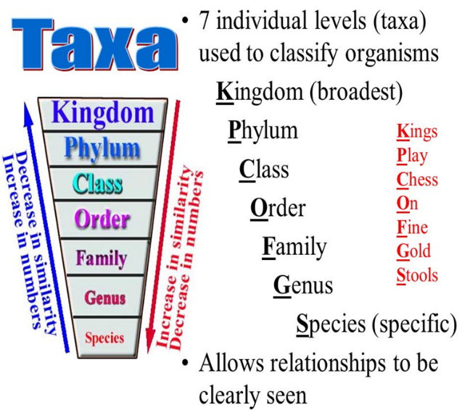

Status of Living and Extinct Taxa
Mammals | Amphibians | Birds

Discussion: What do you think are some of the largest contributing factors of how human activity effects Biodiversity?

