- _________________- The belief that white, wealthy, Anglo-Saxon Americans were biologically superior to other groups
  - The misapplication of biological evolutionary language of Charles _________ to politics, economics, and society
  - Social Darwinists embraced laissez-faire capitalism and ________________.
  - Believed that government should not interfere in the “survival of the _____________” by helping the poor and promoted the idea that some races were biologically superior to others
- _______________ – a set of beliefs and practices that aims at improving the genetic quality of the human race
  - Fitter Family Competitions – at state fairs, families would be judged on their health, quantity of children, heritage, and appearance.
    - What other things do we judge like this? _____________________________
- A History of Racism in America
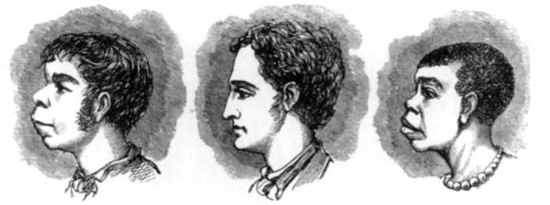
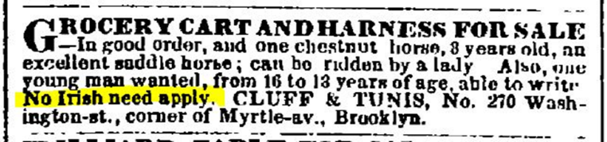

What do you think these images say about America’s opinions of people classified as “non-white”?

