Imperialism – the _______________ and _______________ domination of a strong nation over other weaker nations; example – World power over developing nations
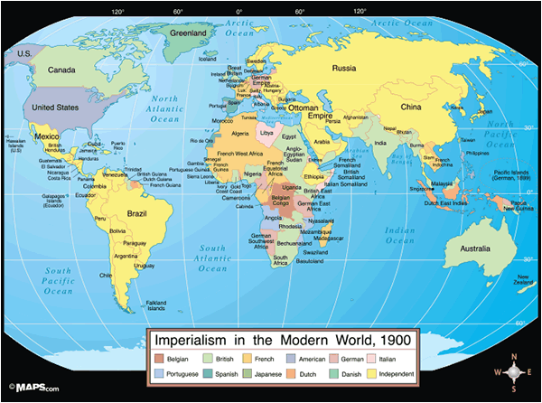
What do you notice about this map? Why is this map different from the modern map?
_________________________________________________________________________________________________________________________________________________________________________________________________________________________________________________________________________________________________________________________________________________________________________________________________________________________________________

Flocabulary – Imperialism Questions
- The Sun never sets on which empire? _____________
- What are the two places the British colonized? ______________ & ________________
- What is the “white man’s burden?” _________________________________________________________________________________________________________________
- What did imperialist claim was their “mission” when they invaded foreign territories? ________________________________________________________________________________________________________________________________________________________________________________________________________________________
- What religion did imperialists want everyone to convert to? _____________________________
- What were two methods of transportation that were used to help colonize Africa? ________________________________________________________________________

Why would a country want to become an Imperial power? ______________________________________________________________________________________________________________________________________________________________________________________________________________________________________________________
A Desire for New Markets
In the late 1880s, Americans wanted to become a ________________, due to economic and _________________ competition from other nations, as well as a growing feeling of cultural superiority.
Europe began to look for more places to expand and invest its capital (______________) and chose countries in _________ and ____________. They began to exert control over those territories, and some become colonies, while many others became protectorates.
________________________- the imperial power allows the ___________ rulers to stay in control and ____________________ them against rebellions and invasions
Why would the Europeans allow some countries to retain local leaders? What are the advantages? ______________________________________________ ____________________________________________________________________________________________________________________________________________________

America began to take notice of this expansion of European influence. America had been expanding since its creation in the 18th century.
What are some examples of territories that America had gained since its founding? _____________________________________________________________ ______________________________________________________________________________________________________________________________________________________
Why would the strategy of expanding across North America no longer work? ______________________________________________________________________________________________________________________________________________________
Indiana ______________ Albert J. Beveridge- “We are raising more than we can consume. We are making more than we can use. Therefore, we must find new markets for our produce, new occupation for our capital, new work for our labor.”
How does this idea influence our modern economy? ______________________ ________________________________________________________________________
Anglo-Saxonism- English speaking nations had ____________ character, ideas, and systems of government and were ______________ to dominate the planet
What pseudoscientific theory is Anglo-Saxonism similar to? _______________
This system of beliefs was popular in __________ and _____________. Many Americans saw it as an extension of _______________________, the belief that it had been the nation’s destiny to expand from Atlantic to Pacific. Now, they believed it was the destiny of America to expand overseas and spread its civilization and ___________________ to others.
Imperialism was closely linked with _____________________ missionary work and the idea that people of Anglo-Saxon ancestry had an obligation to evangelize and civilize the _________________ of non-white countries.
Japan
Commodore Matthew C. ___________________ led the American naval expedition to _________________ to negotiate trade treaty. Four American battleships entered Tokyo Bay. It was a show of ______________ and dominance for America as the Japanese had never seen ___________________.
Japan had had isolationist policies, so they were not an industrialized nation like the ______________________ world. They realized they could not compete with the industry and firepower of the West, and signed trade agreements with the US. As a result, Japan launched its own ___________________ revolution and built its own powerful, modern _________.
Annexation of Hawaii
Hawaii’s tropical _______________ and rich ____________ led American planters to create __________________ plantations on the islands. American governments pressured the Hawaiian King into deals that _______________ his power and ___________________ the influence of the Sugarcane plantation owners. Sugarcane was exempted from importation tariffs, and the Hawaiian people were _______________ with the increased American influence on the islands. It also guaranteed the US a naval base in Hawaii, ___________________________.
The Hawaiian economy was suffering when _____________ Liliuokalani came to power in 1891. In 1893, she tried to reassert her power through a new _____________________________.
Queen Liliuokalani- ______________ Hawaiian monarch; removed in 1893 when she tried to remove Americans from control
Planters supported a coup to _______________________ the Queen, with the help of Marines.
On January 16, 1893, 162 US Marines marched off the warship Boston and onto the shores of Oahu, one of the Hawaiian Islands. John L Stevens, the American Minister to Hawaii, had ordered the _____________ ashore. He claimed Hawaii’s ruler, Queen Liliuokalani, had created widespread turmoil and endangered American _____________ and _________________. Stevens had other motives as well. He wanted to make Hawaii, with its profitable sugarcane plantations, part of the United States.
Stevens ordered the American troops to take up positions near Queen Liliuokalani’s palace. Although, the marines took no action against the Hawaiian government, their presence _________________________ the Queen’s supporters. Within hours, the American settlers in Hawaii abolished the monarchy and set up a provisional - or temporary- government. On February 1, 1893, at the request of the provisional government, Stevens announced that Hawaii was now under American protection, and he hoisted the _________________ flag over Hawaii’s government buildings. Several weeks later, Stevens made his support for annexing Hawaii perfectly clear: “The Hawaiian ___________ is not fully ripe,” he wrote, “and this is the golden hour for the United States to ___________ it.” – Adapted from A History of the American People.
President Grover Cleveland did not _____________________ imperialism and tried to restore Liliuokalani. Hawaii’s leaders waited for the next president, who they hoped would be more sympathetic. Hawaii was ______________ in 1898.
Who pushed for the annexation of Hawaii- President Cleveland, American Sugar Growers, or the Hawaiian people? _________________________________ ______________________________________________________________________________________________________________________________________________________

Latin America
Pan-Americanism- the idea that the US and Latin America should _________ together
Monroe Doctrine- written by President James _____________ in 1823; American policy that Europe should stay out of the Western Hemisphere (the Americas)
Americans were concerned that in order to ____________ their overseas trade deals and territories, they would need battleships to fight foreign powers. Alfred T. Mahan argued that building a navy made sense for the US, and to support this navy, the US would need to acquire ___________ overseas bases to supply the _____________ needed to fuel the ships.
Spanish American War
The battleship, ____________________, floated in the harbor of Havana, Cuba. On February 15,1898, it exploded and killed ______________ officers and sailors of the 354 on board. People argued whether it was:
- _________________________________________________________________________________________________________________________________________,
- ______________________________________________________________________________________________________________________________________________________________________________________________________________.
Many Americans blamed it on _____________. Cuba was a Spanish colony and fighting for _____________________________. Within weeks, America and Spain were at _____________ and America’s position on the world stage was about to ____________________ dramatically.

