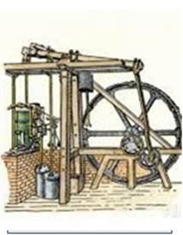
Improved Steam Engine
Invented by James Watt
Allowed for a more powerful engine that would lead to increases in productivity during the Industrial Revolution
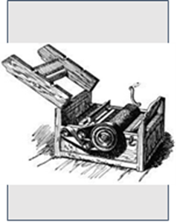

Cotton Gin
Invented by Eli Whitney
Increased cotton production dramatically but also increased the demand for slavery in order to ramp up amount of cotton picked
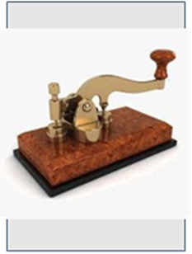
Telegraph
Invented by Samuel Morse
Allowed for instant communication across great distances for the 1st time in history

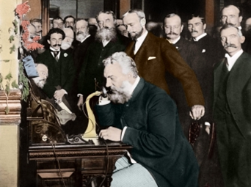
Telephone
Invented by Alexander Graham Bell
Allowed for people to speak rather than use Morse code to communicate across distances
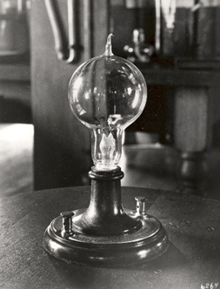
Light Bulb
Invented by Thomas Alva Edison
Allowed for cheap, safe light to be used by the general public
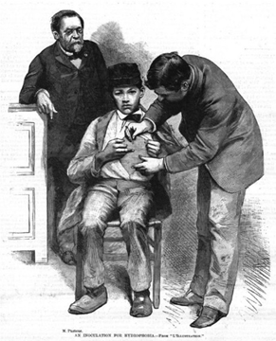
Pasteur’s Vaccine
Invented by Louis Pasteur
Discovered bacteria that caused disease and created safe vaccines against diseases that killed many

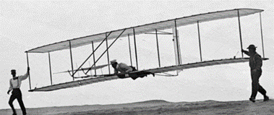
Airplane
Invented by Wright Brother
Would drastically change transportation and warfare in a short time with successful test flight

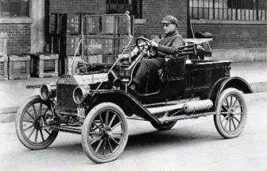
Model T Car
Invented by Henry Ford
First successful use of mass production to create a car that many people could afford

