Name ________________________________________
Chemistry I Honors
Properties of Matter
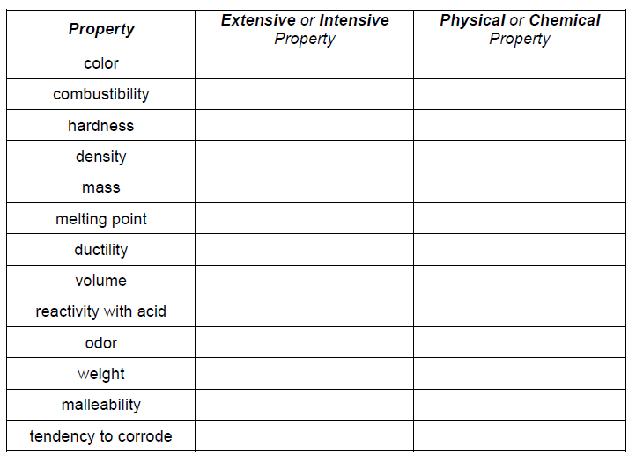

Name ________________________________________
Chemistry I Honors
Properties of Matter

