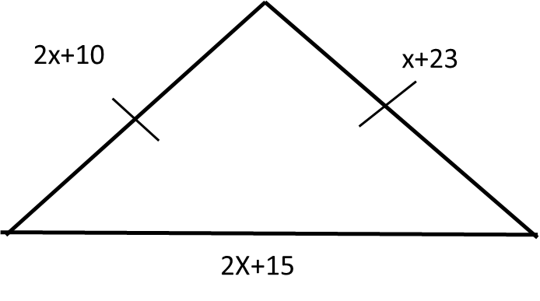

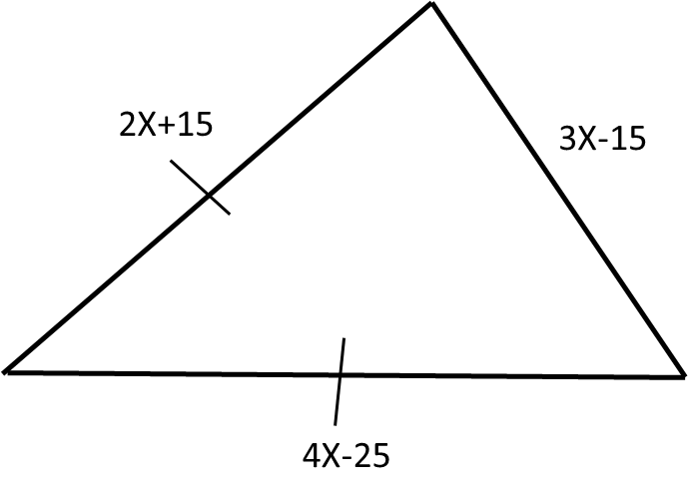

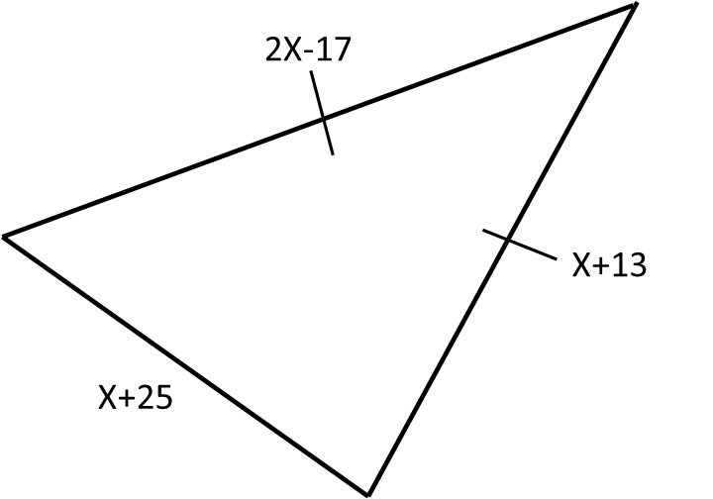

Name: ______________________________________________ Date: ______________

Section Name: ____________________________________________

*Write down the properties of isosceles triangles.

