Historical Investigation — The Original Renaissance Man

Directions: In order to answer the focus question, you must first consider the source, purpose, and content of each historical document. You must also consider how the content of each document corroborates (strengthens) or contradicts evidence found in other documents. Examine all the documents and then answer the questions that follow. This will assist you in answering the focus question at the end of the investigation.

Focus Question: Does Leonardo da Vinci deserve the title “Renaissance Man?”

Document 1: Map of Imola, Italy (c. 1502)
Da Vinci was first hired to create maps of a town in Florence, Italy, in order to better defend it from invading armies. The map here of Imola, a town in central Italy, was made for Cesare Borgia and includes incredible detail considering the lack of overhead views.
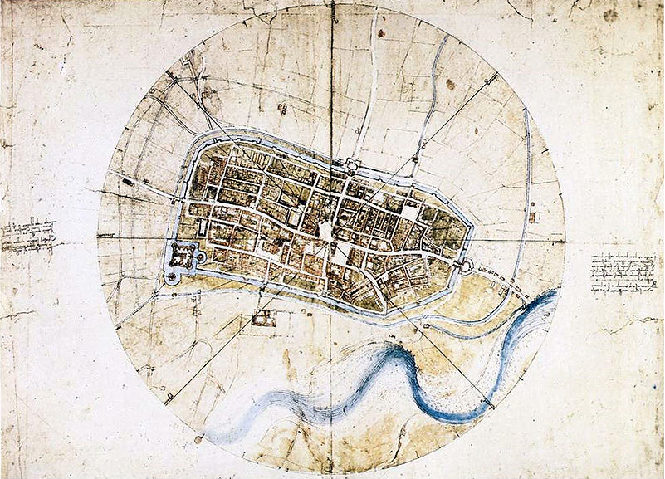
Caption: Map of Imola, Italy (c. 1502)
Source: This image from http://en.wikipedia.org/wiki/File:Leonardo_da_vinci,_Town_plan_of_Imola.jpg is in the public domain because its copyright has expired.
- Identify the source and type of document.

- What is the message of the document?

- Why was this document created? What was its purpose?

- Does this document corroborate (support) or contradict the others? Why or why not?

- How might this document help you answer the focus question?

Focus Question: Does Leonardo da Vinci deserve the title “Renaissance Man?”

Document 2: Design For a Flying Machine (c. 1488)
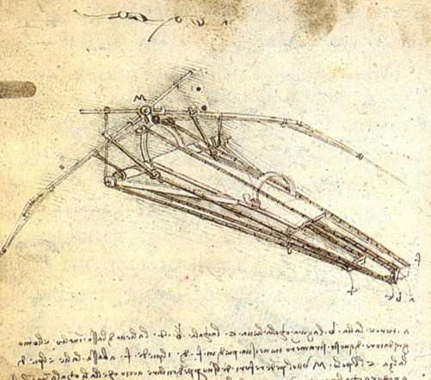
Da Vinci also drew designs for technologically advanced ideas that would eventually be created only hundreds of years afterward, following the industrial era. In addition to the primitive airplane shown here, da Vinci drew advanced designs of helicopters, river dams, and hydraulic dams.

Caption: da Vinci’s design for a flying machine
Source: This image from http://en.wikipedia.org/wiki/ File:Design_for_a_Flying_Machine.jpg is in the public domain because its copyright has expired.

- Identify the source and type of document.

- What is the message of the document?

- Why was this document created? What was its purpose?

- Does this document corroborate (support) or contradict the others? Why or why not?

- How might this document help you answer the focus question?

Document 3: The Last Supper (1498)
The Last Supper remains one of the most recognizable works of Renaissance art. It portrays a biblical scene focused on the central figure of Jesus, and uses a linear style to show depth and focus the viewers’ attention. Da Vinci mastered the use of scientific principles to produce realistic scenes.
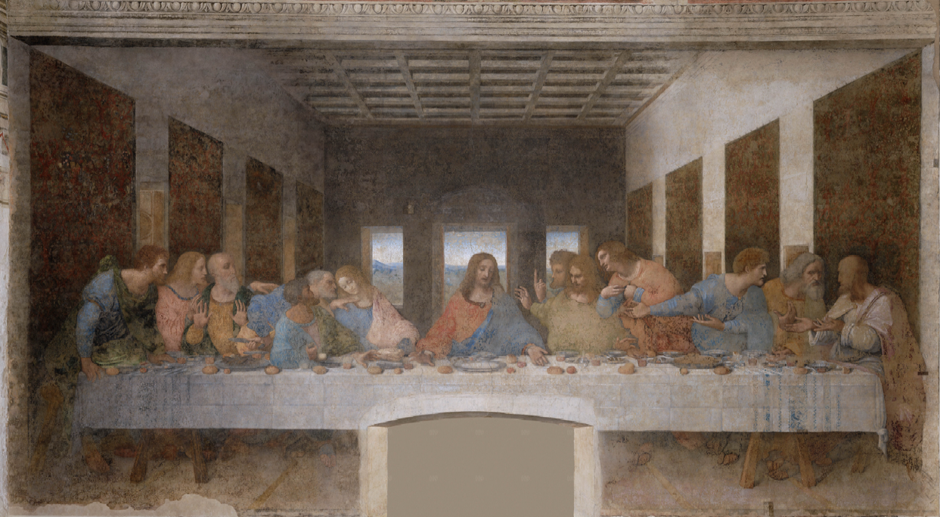
Caption: Leonardo da Vinci’s “Last Supper”
Source: The image from http://en.wikipedia.org/wiki/File:Última_Cena_-_Da_Vinci_5.jpg is in the public domain because its copyright has expired.

- Identify the source and type of document.

- What is the message of the document?

- Why was this document created? What was its purpose?

- Does this document corroborate (support) or contradict the others? Why or why not?

- How might this document help you answer the focus question?

Focus Question: Does Leonardo da Vinci deserve the title “Renaissance Man?”

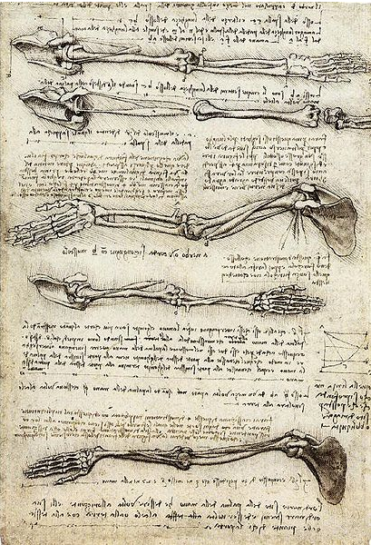
Document 4: Drawing of Human Arm (c. 1510)
As an apprentice, da Vinci also learned about human anatomy and often recorded his knowledge in journals. Found in a journal, “Studies of the Arm Showing the Movement of the Biceps” demonstrated his amazing ability to recreate lifelike images of complicated parts of the human body.

Caption: Drawing of Human Arm
Source: This image from http://en.wikipedia.org/wiki/ File:Studies_of_the_Arm_showing_ the_Movements_made_by_the_Biceps.jpg is in the public domain because its copyright has expired.

- Identify the source and type of document.

- What is the message of the document?

- Why was this document created? What was its purpose?

- Does this document corroborate (support) or contradict the others? Why or why not?

- How might this document help you answer the focus question?

Focus Question: Does Leonardo da Vinci deserve the title “Renaissance Man?”

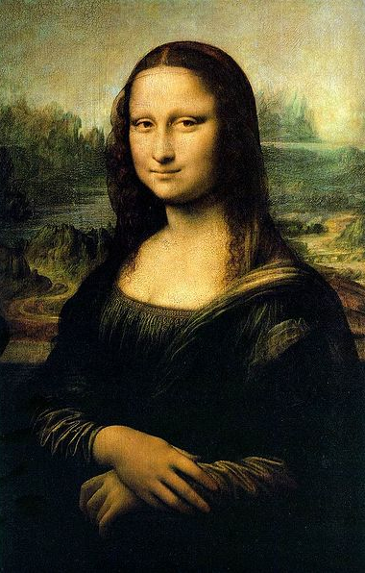
Document 5: Mona Lisa (1507)
The Mona Lisa remains, arguably, the most famous painting in world history. It reflects many of da Vinci’s talents, such as the use of light and shadow and the use of human expression. The positioning of the figure, also known as La Gioconda or “Laughing One” also gives the viewer the illusion of being followed by the figure’s eyes.

Caption: Mona Lisa
Source: This image from http://en.wikipedia.org/wiki/File:Mona_Lisa.jpeg is in the public domain because its copyright has expired.

- Identify the source and type of document.

- What is the message of the document?

- Why was this document created? What was its purpose?

- Does this document corroborate (support) or contradict the others? Why or why not?

- How might this document help you answer the focus question?

Focus Question: Does Leonardo da Vinci deserve the title “Renaissance Man?”

Document 6: Renaissance Era Admirer
As advances in engineering and other sciences progressed, praise for da Vinci’s work grew throughout modern history. However, some contemporary observers of da Vinci’s work also applauded his talents. In the following excerpt from Lives of the Most Eminent Italian Architects, Painters and Sculptors (1550), author Giorgio Vasari commends da Vinci’s abilities.

And he practiced not one branch of art only, but all those in which drawing played a part; and having an intellect so divine and marvelous that he was also an excellent geometrician, he not only worked in sculpture, making in his youth, in clay, some heads of women that are smiling, of which plaster casts are still taken, and likewise some heads of boys which appeared to have issued from the hand of a master; but in architecture, also, he made many drawings both of ground-plans and of other designs of buildings; and he was the first, although but a youth, who suggested the plan of reducing the river Arno to a navigable canal from Pisa to Florence. He made designs of flour-mills, fullingmills, and engines, which might be driven by the force of water;…

Source: Medieval Sourcebook, http://www.fordham.edu/halsall/source/vasari1.html

- Identify the source and type of document.

- What is the message of the document?

- Why was this document created? What was its purpose?

- Does this document corroborate (support) or contradict the others? Why or why not?

- How might this document help you answer the focus question?

Focus Question: Does Leonardo da Vinci deserve the title “Renaissance Man?”

Now, consider your responses to the questions as you viewed each of the documents about The Renaissance Man, Leonardo da Vinci.

- Identify the source and type of the document.
- What is the message of the document?
- Why was this document created? What was its purpose?
- Does this document corroborate (support) or contradict other ones? Why or why not?
- How might this document help you answer the focus question?

Answer the following question based on your review of documents 1 through 6.

Does Leonardo da Vinci deserve the title “Renaissance Man?”

- Analyze da Vinci’s accomplishments during the Renaissance.
- How do da Vinci’s accomplishments stand out in an era of great change?
- Include details and examples to support your answer.

