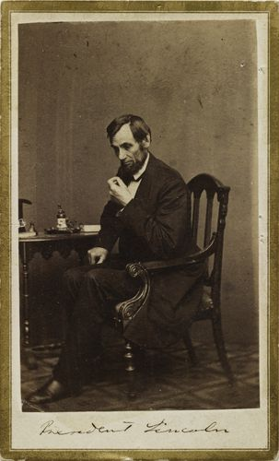
Mathew B. Brady’s Portrait of President Lincoln
One of the earliest American photographers and the owner of a successful photography studio, Mathew B. Brady photographed celebrities, presidents, and, most famously, scenes of his country’s Civil War. From 1860 to 1864, his studio made more than 30 portraits of President Abraham Lincoln. Among them is this thoughtful and introspective image, made when the president had been in office for two years, and one year into the Civil War. President Lincoln understood the power of these portraits and used photography to his advantage, acknowledging, “Brady and The Cooper Union speech made me president of the United States.”
Many of Brady’s photographs of President Lincoln were reproduced on buttons and posters and, in the case of this image, as cartes de visites. These pocket-sized photographs served as visual calling cards and were an inexpensive and popular way of distributing portraits and self-portraits, which people often collected in albums. Those picturing President Lincoln—in particular a portrait taken on February 27, 1860, after the speech at The Cooper Union, in New York City, that launched his presidential campaign—sold widely. Cartes de visites became a valuable political tool. For the first time in history, they enabled a broad segment of the American public to actually see their presidential candidates (an ability taken for granted today).
Touch-ups Fit for a President: Brady touched-up many of his portraits of President Lincoln to correct such slight physical abnormalities as his wandering eye. The resulting images helped to dispel rumors that the tall and awkward Lincoln suffered from serious physical deformities.
Questions
- How did Mathew Brady portray President Lincoln in the photograph shown in the text?
- Why might pocket-sized photographs have been “a valuable political tool” for presidential candidates? Support your answer with details from the text.
- How did Mathew Brady affect the way the American public viewed Abraham Lincoln? Support your answer with details from the text.
- What is the main idea of this text?
- President Lincoln said that Mathew Brady helped make him president of the United States. What evidence from the text supports Lincoln’s statement?

