Name: __________________________ Date: ________________

Matching Histograms to Boxplots
Consider all of the graphs below, the histograms and the boxplots, to be on the same scale. Match each histogram with its corresponding boxplot, by writing the letter of the box plot in the space provided.
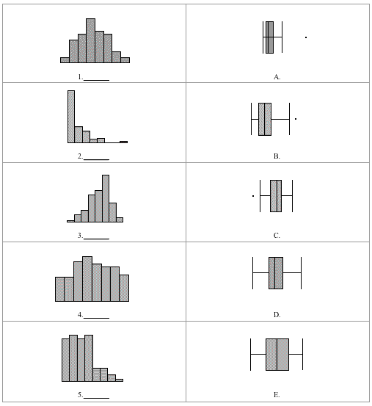

Please note the possible student answers may not, in some cases, be IDEAL student answers

