Directions: Correctly measure the length of each line and complete the items below the rulers.
Line 1:
_________________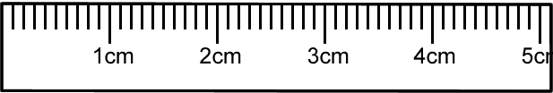
Line 2:
_________________________________________________________________________
Line 3:
_________________________________________________
Line 1
Measurement: __________ Certain digit(s): __________ Uncertain digit: __________ Total number of significant figures: __________
Line 2
Measurement: __________ Certain digit(s): __________ Uncertain digit: __________ Total number of significant figures: __________
Line 3
Measurement: __________ Certain digit(s): __________ Uncertain digit: __________ Total number of significant figures: __________

