**Darwin’s Natural Selection Worksheet Name ___________________________________**

Read the following situations below and identify the 5 points of Darwin’s natural selection.

1) There are 2 types of worms: worms that eat at night (nocturnal) and worms that eat during the day (diurnal). The birds eat during the day and seem to be eating ONLY the diurnal worms. The nocturnal worms are in their burrows during this time. Each spring when the worms reproduce, they have about 500 babies but only 100 of these 500 ever become old enough to reproduce.

a. What worm has natural selection selected AGAINST? _________________ FOR? ________________

Darwin's 5 points: Identify the 5 points in the scenario above.

Population has variations. _________________________________________________________________

Some variations are favorable. _____________________________________________________________

More offspring are produced than survive._________________________________________________

Those that survive have favorable traits. ____________________________________________________

A population will change over time. ________________________________________________________

2) There are 3 types of polar bears: ones with thick coats, ones with thin

coats and ones with medium coats. It is fall, soon to be winter. The

temperatures are dropping rapidly and the bears must be kept warm,

or they will freeze to death. Many of the bears have had ~2 cubs each

but due to the extreme temperatures, many mothers only have one

cub left.

a. What bear will natural selection select AGAINST? ___________________ FOR? _________________

Darwin's 5 points: Identify the 5 points in the scenario above.

Population has variations. _________________________________________________________________

Some variations are favorable. _____________________________________________________________

More offspring are produced than survive._________________________________________________

Those that survive have favorable traits. ____________________________________________________

A population will change over time. ________________________________________________________



3) In ostriches, there are 2 types: ones that run fast and those that run slowly. The fast birds can reach up to 40 miles an hour. Jackals love to eat ostrich, and they can reach speeds of up to 35-40 miles per hour. A flock of ostrich will lay ~ 10 eggs (each mother only lays 1), but many rodents break into the eggs and eat the fetus before they hatch.

a. What ostrich will natural selection select AGAINST? __________________ FOR? ________________

Darwin's 5 points: Identify the 5 points in the scenario above.

Population has variations. _________________________________________________________________

Some variations are favorable. _____________________________________________________________

More offspring are produced than survive._________________________________________________

Those that survive have favorable traits. ____________________________________________________

A population will change over time. ________________________________________________________

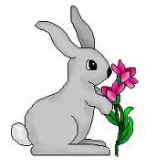

4) There are two types of rabbits: those that strictly eat grass and those

that strictly eat berries and flowers. A drought occurs one year, and the

plants have difficulty producing any extras (flowers, berries, etc.).

They can only try and keep themselves green. The rabbits have

had babies all year long but many are eaten by foxes or hawks

Due to the drought, many have starved to death.

a. What rabbit will natural selection select AGAINST? __________________ FOR? _________________

Darwin's 5 points: Identify the 5 points in the scenario above.

Population has variations. _________________________________________________________________

Some variations are favorable. _____________________________________________________________

More offspring are produced than survive._________________________________________________

Those that survive have favorable traits. ____________________________________________________

A population will change over time. ________________________________________________________



5) Bob believes that giraffes have long necks because they have stretched their necks to try and reach food that is high in trees. Since the parent had stretched its neck, it passed the long neck on to its offspring.

Ryan believes that giraffes have long necks because the ones with long necks were able to reach the food, and those with short necks could not and died. The long necked giraffes reproduced, and soon all of the giraffes had long necks.

a. Who thinks like Lamarck? __________________________________________________

b. Who thinks like Darwin? ___________________________________________________

**Types of Natural Selection:**

Stabilizing Selection-- The extremes are selected against.

Example: height; mostly beings tend to the average height- not too many really short ones or really tall ones.

Directional selection-- One extreme value is selected for.

Example: speed; faster is always better so a population will tend to get faster over time.

Disruptive selection-- The extremes are both selected for.

This type of selection is not as common as the first two. Example: Prey-type animal with distinctive markings which the predators know will over time move away from the norm in both directions.

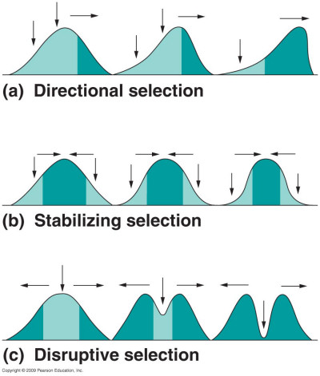

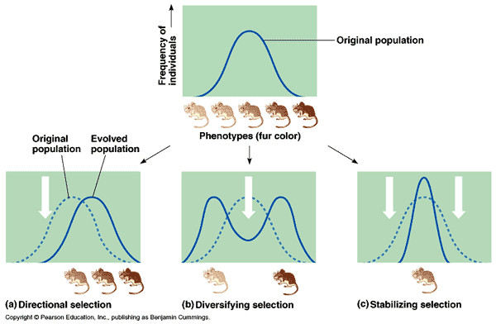

1. Long necks make it easier for giraffes to reach leaves high on trees, while also making them better fighters in “neck wrestiling” contests. In both cases, which kind of selction apears to have made giraffes the long-necked creaturs they are today?
   1. Directional selection
   2. Stabilizing selection
   3. Disruptive selection
2. Women often have complications during labor while giving birth to very large babies, whereas very small babies tent to be underveveloped. This situation results in which kind of selection on birth weight?
   1. Directional selection
   2. Stabilizing selection
   3. Disruptive selection
3. Black-bellied seedcrackers have either small beaks (better for eating soft seeds) or large beaks (better for hard seeds). There are no seeds of intermediate hardness; therfore, which kind of selection acts on beak size seedcrackers?
   1. Directional selection
   2. Stabilizing selection
   3. Disruptive selection
4. Small *Aristelliger* lizards have difficulty defending territories, but large lizards are ore likely to be preyed upon by owls. This situation results in what kind of selection on adult body size?
   1. Directional selection
   2. Stabilizing selection
   3. Disruptive selcetion