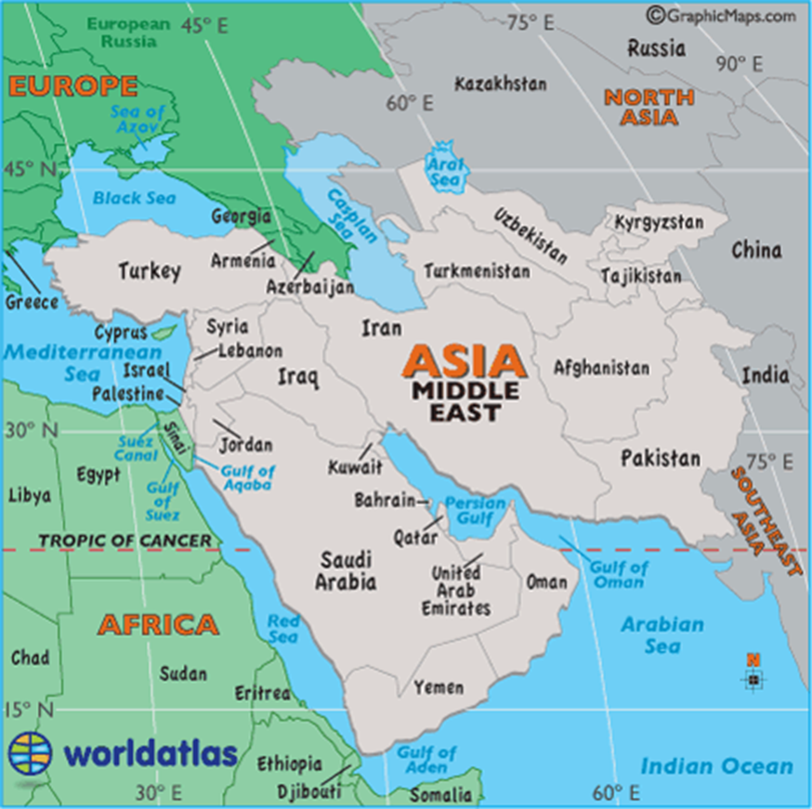
- The Middle East and South East: 1450-1650
  - Known as the “age of ______________ empires”
  - The Empires of the Middle East and South East are
    - Mughal __________
    - Ottoman Empire (______________)
  - _________________ ruled India
  - ________________ in modern day Turkey
- The Middle East: 1450-1650
  - All had _______________, ___________________, and ______________, reducing the need for ordinary foot soldiers
  - Why did they want fire arms?
    - __________________________________________________
    - __________________________________________________
    - __________________________________________________________________________________________________________________________________
- The Pre-Mughal Empire
  - Hindu and Buddhist __________________ controlled India before the establishment of the Mughal Empire
  - Huge trade network with Middle East, Southeast Asia, and China
    - Along the _________________ and ________________ trade routes
- Sultan’s defeat Hindus
  - _____________ = Muslim Leader
  - Late 1100s-1526= Muslim rule (ruled by Sultans)
  - Why did the Muslims win?
    - __________________________________________________________________________________________________________________________________
    - __________________________________________________________________________________________________________________________________
    - __________________________________________________________________________________________________________________________________
- Muslim and Hindu Religion Clash
  - Buddhism declines due to Muslim destruction

Hinduism Muslim

- Sultans
  - Grew ______________ of Hindu subjects
  - Could Practice with the payment of a ________________
  - Merchants converted to Islam because it ___________________ their trade network
- Akbar the Great
  - ________________ (1483-1530) founds empire in 1526-1857
    - First Mughal Emperor
  - Babur’s grandson, ______________ (1542-1605) takes control
    - Established _____________ central government
    - __________________
    - Supported Hindus
      - Allowed them to hold government office
      - Ended tax to non-Muslims
      - Married a ______________
- Shah Jahan
  - ________________ (1592-1666)
  - Akbar’s grandson
  - High point in Mughal’s history (made lots of ________)
  - Known for marrying Mumtaz Mahal
    - Built a tomb for her called the ________________________
Write 6 facts about the Taj Mahal based on the video. https://www.history.com/topics/india/taj-mahal

Timeline –
____________ >> Hamayun>>>_____________ the Great>>>>Emperor Jahangir>>>_____ Jahan

- Downfall of the Mughal Empire
  - Successors are not as ___________ of Hindus
  - Heavy _____________ = economic hardships = Hindu revolts
  - ___________________ traders take advantage of the weakened empire
- Constantinople Falls to the Ottomans
  - Byzantine Empire controlled ______________________________
  - Mehmet II (________________) captures it
    - Renames Capital ______________________
- The Ottoman Economy
  - TRADE, TRADE, TRADE
  - Products: _______________ and __________________ (produced in the Empire); items from India and China
- Ottoman Culture Class System
  - Men of the Sword
    - ____________________
    - ______________________
  - Men of the Pen
    - ____________________
    - ___________________
    - ______________________
  - Men of Negotiation
    - ___________________
    - ___________________,
    - ___________________
  - Men of Husbandry
    - _________________,
    - _________________,
    - ___________________
- What are Janizaries
  - Young ______________________ boys were sent to the palace for government service
    - Converted to ______________
    - Religious military training
    - Best soldiers won the title of _________________
    - Were able to serve the Muslim government
- Ottoman Religion
  - Islamic religion was used to _________________ the areas that were conquered
    - These areas are typically ________________ Muslim today
- Decline of the Ottomans
    - Suleiman died in 1556 and his most able son was killed
    - Successors were _________________
      - European countries saw this as an opportunity to take land

