Chapter 3: Tissues
- Body Tissues
  - Cells are ___________________________ for particular functions
  - Tissues
    - Groups of cells with similar ___________________________ and ___________________________
    - Four primary types
      - ___________________________
      - ___________________________ tissue
      - ___________________________ tissue
      - ___________________________
- Epithelial Tissues
- Found in different areas
  - Body ___________________________
  - Body ___________________________
  - ___________________________ tissue
- Functions
  - Protection
  - Absorption
  - Filtration
  - Secretion
  - Epithelium Characteristics
    - Cells fit closely together
    - Tissue layer always has one free surface
    - The lower surface is bound by a ___________________________ membrane
    - ___________________________ (have no blood supply)
    - Regenerate easily if well nourished
  - Classification of Epithelium
    - Number of cell layers
      - ___________________________ – one layer
      - ___________________________ – more than one layer
    - Shape of cells
      - ___________________________ – flattened
      - ___________________________ – cube-shaped
      - ___________________________ – column-like
  - Simple Epithelium
    - Simple squamous
      - Single layer of flat cells
      - Usually forms membranes
        - Lines body cavities
        - Lines lungs and capillaries
    - Simple cuboidal
      - Single layer of cube-like cells
      - Common in ___________________________ and their ducts
      - Forms walls of ___________________________ tubules
      - Covers the ovaries
    - Simple columnar
      - Single layer of tall cells
      - Often has ___________________________ cells (which produce mucus)imbedded in it
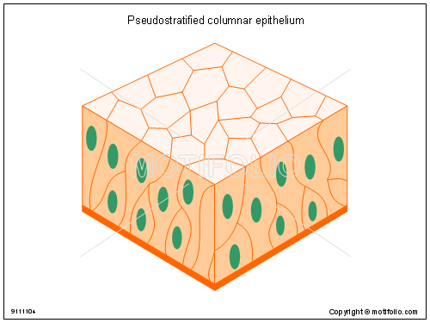
      - Lines ___________________________ tract
    - Pseudostratified
      - Single layer, but some cells are shorter than others
      - Often looks like a double cell layer
      - Sometimes ___________________________, such as in the ___________________________ tract
      - May function in absorption or secretion
  - Stratified Epithelium
    - Stratified squamous
      - Cells at the ___________________________ edge are flattened
      - Found as a ___________________________ covering where friction is common
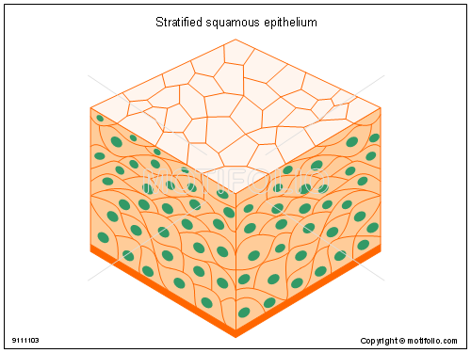
      - Locations
        - ___________________________
        - Mouth
        - Esophagus
    - Transitional epithelium
      - Subclass of Stratified Squamous that lines only a few organs
      - Shape of cells depends upon the amount of ___________________________
      - Lines organs of the ___________________________ system
    - Stratified cuboidal
      - Two layers of cuboidal cells

    - Stratified columnar
      - Surface cells are columnar, cells underneath vary in size and shape
    - **Stratified cuboidal and columnar are ___________________________ in human body and are found mainly in ducts of large glands
  - Glandular Epithelium
    - Gland – one or more cells that ___________________________ a particular product
    - Two major gland types
      - ___________________________ gland
        - Ductless
        - Secretions are hormones
      - ___________________________ gland
        - Empty through ducts to the epithelial surface
        - Include sweat and oil glands
- Connective Tissue
  - Found ___________________________ in the body
  - Includes the most abundant and widely distributed tissues
  - Functions
    - ___________________________ body tissues together
    - ___________________________ the body
    - Provides ___________________________

  - Connective Tissue Types
    - There are 5 types of connective tissue
Supporting Connective Tissues
      - Bone (___________________________) Tissue
      - Cartilage
Connective Tissues Proper
      - Dense Connective Tissue (_________________ & __________________)
      - Loose Connective Tissue
Fluid Connective Tissues
      - Blood
  - Connective Tissue Characteristics
    - Variations in ___________________________ supply
      - Some tissue types are well vascularized
      - Some have poor blood supply or are avascular
    - Made of cells and an extracellular matrix
      - Extracellular matrix is a _____________ material that surrounds living cells
    - Extracellular ___________________________
      - Non-living material that surrounds living cells
      - Two main elements
        - ___________________________ – mostly water along with adhesion proteins and polysaccharide molecules
        - ___________________________
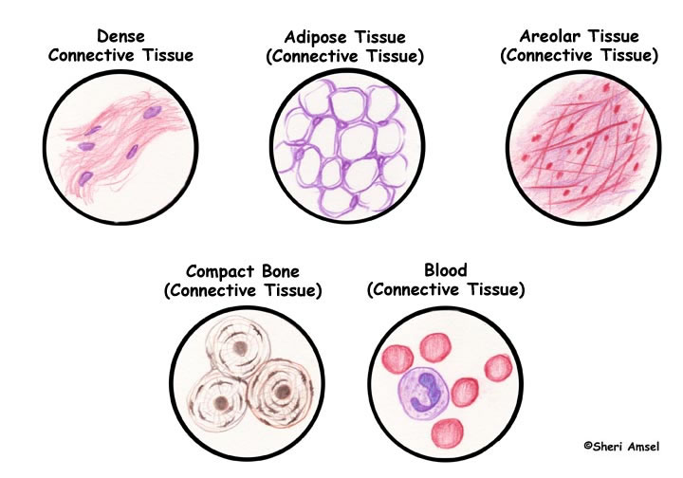
          - Produced by the cells
            - Three types
              - _______________ fibers- made of the triple-stranded coiled protein collagen (thickest)
              - _______________ fibers- made of a proteinaceous substance Elastin which has only about .1 the tensile strength of collagen (thinnest)
              - ______________ fibers- made of the triple-stranded coiled protein collagen
  - Connective Tissue Types
    - Bone (osseous tissue)
      - Composed of:
        - Bone cells (osteocytes) in ___________________________ (cavities)
        - ___________________________ matrix of calcium salts
      - Large numbers of collagen fibers
      - Used to ___________________________ and ___________________________ the body
    - Hyaline cartilage
      - Most ___________________________ cartilage used for support and reinforcement
      - Composed of:
        - Abundant collagen fibers
        - ___________________________ matrix
        - Chondrocytes (___________)
      - Entire fetal skeleton is hyaline cartilage, found on ends of long bones, found attaching ribs to sternum
    - Elastic cartilage
      - Provides ___________________________(flexibility)
      - Consists of elastic fibers and chondrocytes in a rubbery matrix
      - Example: supports the external _____________
    - Fibrocartilage
      - Highly ___________________________ to absorb shock
      - Found in intervertebral __________ between vertebrae, in the knee, and in the pubic symphisis
      - Consists of thick collagen fibers and chondrocytes in a rubbery matrix (less rubbery than hyaline)
    - Dense Regular Connective Tissue
      - Main matrix element is collagen fibers with a few elastic fibers.
      - Very little ground substance because of the number of fibers
      - Cells are __________________ (cells)
      - Found in ______________ (attach muscle to bone) and ____________ (attach bone to bone)
    - Dense Irregular Connective Tissue
      - Main matrix element is collagen fibers with some elastic fibers.
      - Very little ground substance because of the number of fibers
      - Cells are fibroblasts (cells)
      - Found in _______________ of skin
    - Areolar connective tissue
      - Most widely distributed connective tissue
      - ___________________________, pliable tissue that wraps and cushions organs, can also soak up excess fluid
      - Contains ________ fiber types and ____________________ in a gel-like matrix
    - Adipose tissue (Fat)
      - Matrix is an areolar tissue in which fat globules predominate
      - Many cells contain large lipid deposits that cause the _______________ to shift to the edge of the ___________________ (cell)
      - Functions
        - ___________________________the body
        - ___________________________some organs
        - Serves as a site of ___________________________storage

    - Reticular connective tissue
      - Delicate network of interwoven __________________ fibers and blood cells in a gel-like matrix
      - Forms stroma (___________________________ supporting
network) of lymphoid organs
        - Lymph nodes
        - Spleen
        - Bone marrow
    - Blood
      - Red and white blood cells surrounded by _________________________ matrix
      - ___________________________are visible during clotting
      - Functions as the transport vehicle for materials throughout the entire body
- Muscle Tissue
  - Function is to produce ___________________________
  - Three types
    - ___________________________muscle
    - ___________________________muscle
    - ___________________________muscle
  - Muscle Tissue Types
    - Skeletal muscle
      - Can be controlled ___________________________
      - Cells attach to ___________________________tissue
      - Cells are ___________________________
      - Cells have more than one nucleus
    - Cardiac muscle
      - Found only in the ___________________________
      - Function is to ___________________________blood (involuntary)
      - Cells attached to other ___________________________muscle cells at intercalated disks
      - Cells are striated
      - One nucleus per cell
    - Smooth muscle
      - ___________________________muscle
      - ___________________________hollow organs
      - Attached to other ___________________________muscle cells
      - No visible striations
      - One nucleus per cell
      - _________________- a wavelike motion
that moves materials through hollow organs.
- Nervous Tissue
  - ___________________________and nerve
___________________________cells
  - Function is to send impulses to other areas of the body
    - ___________________________
    - ___________________________
- Tissue Repair
  - Regeneration
    - ___________________________of destroyed tissue by the same kind of cells
  - Fibrosis
    - Repair by dense fibrous connective tissue
(___________________________ tissue)
  - Determination of method
    - Type of tissue damaged
    - Severity of the injury
  - Events in Skin and Mucous Membrane Tissue Repair
    - ___________________________become very permeable
      - Introduce clotting proteins
      - Wall off injured area
    - Formation of granulation tissue
      - ___________________________tissue is composed of new capillaries that provide blood to the damaged area and will destroy eventually the clot once it is no longer needed
    - Regeneration of ___________________________epithelium
  - Regeneration of Tissues
    - Tissues that regenerate easily
      - ___________________________tissue
      - ___________________________connective tissue and ___________________________
    - Tissues that regenerate poorly
      - ___________________________muscle
    - Tissues that are replaced largely with scar tissue
      - ___________________________muscle
      - ___________________________tissue within the brain and spinal cord

- Developmental Aspects of Tissue
  - Epithelial tissue arises from all three primary germ layers
  - Muscle and connective tissue arise from the mesoderm
  - Nervous tissue arises from the ectoderm
  - With old age there is a decrease in mass and viability in most tissues
