DNA: Deoxyribonucleic Acid Notes Organizer
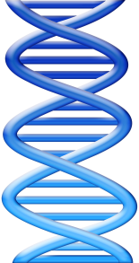
- DNA belongs to the class of organic molecules known as ________________________.
- Made up of monomers called _______________________.
- Remember the other molecules we learned:
  - _________________
  - _________________
  - _________________
Where is it found in the cell?
- DNA condenses to form __________________
- Remember that chromosomes are in the ____________ of a cell
- There is also a little bit of DNA found in the mitochondria.
What does it look like?
- A twisted ladder, known as a ___________________.
- There are _____ strands of DNA that make up the double helix
A Closer Look at a DNA Nucleotide
- Deoxyribose + Phosphate + Nitrogenous Base
- 4 Different Nitrogenous Bases
  - _________________
  - _________________
  - _________________
  - _________________

Bases are Grouped by Structure
- _____________- 2 rings
  - Adenine
  - Guanine
- ________________- 1 ring
  - Cytosine
  - Thyamine

Purines Always Pair to Pyrimidines
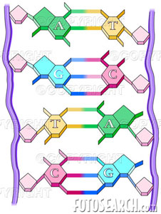
- Adenine to ______________ (2 rings + 1 ring= 3 rings)
- Guanine to ______________ (2 rings + 1 ring= 3 rings)
- This keeps the lengths of the “rungs” the same length.
- _____________________ bonds form between the purines and pyrimidines.
What does the Ladder Look Like?
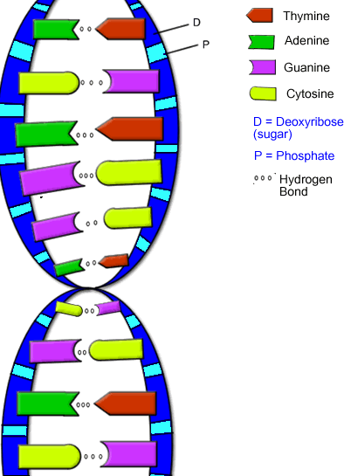
- The “rungs” of the ladder are made up of ____________.
- The sides of the ladder are made up of the ______________ and __________________ part of the nucleotide
- Notice the deoxyribose and phosphate _______________
Rosalind Franklin
- Was the first to __________________ DNA
  - But she is rarely given much _______________!
Q: Who gets the credit?
- A: __________________ and _________________
- In 1953, they used Franklin’s photograph and other experimental evidence to come up with the idea that DNA is in the ___________________________________________.
- We now have lots of evidence to show that Watson, Crick and Franklin were correct about DNA!
- Watson and Crick won the Nobel Peace Prize in 1962 for their discovery of the ___________________ of DNA

