Ecological Footprints – Notes Organizer Name __________________________

Ecological Footprint – ________________________________________________________________
____________________________________________________________________________________
____________________________________________________________________________________
____________________________________________________________________________________

What Ecological Footprints Tell Us
- Ecological Footprints help show ___________________________________________ __________________________________ that is required to sustain the human activity.
- Ecological footprints show us the impact of __________________________________ and the amount of resources necessary to produce the goods and services necessary to support a particular lifestyle, in terms of the area of ____________________________ _________________________________________________________.
- It also measures ________________________________________________________, and what we consume and dispose of.

How Ecological Footprints are Calculated
The following 6 categories are considered when calculating ecological footprints:
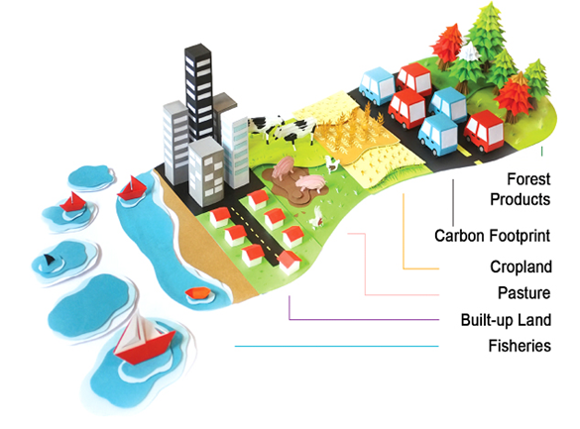

8 Ways to Reduce Ecological Footprints

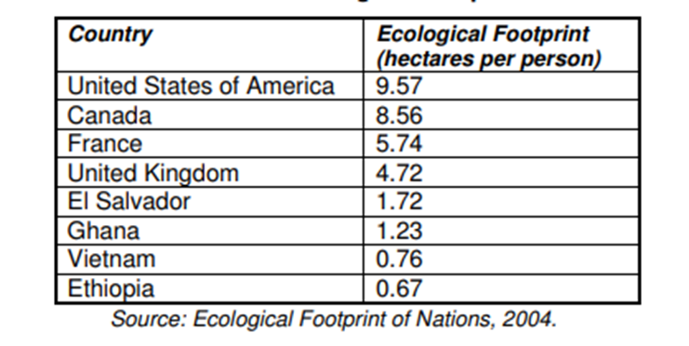

The World’s Ecological Footprints
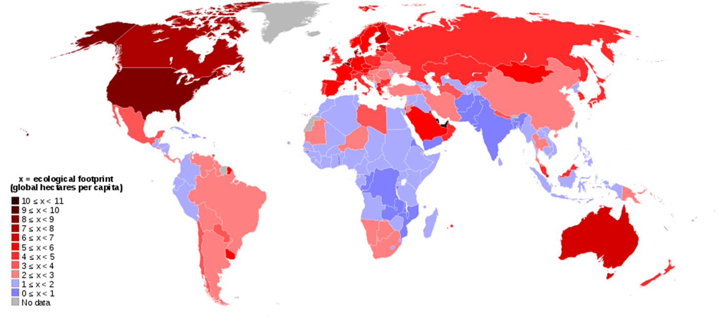

Prediction: If everyone on Earth lived the way you did, predict how many Earths would be needed to support the human population adequately?

