Name: _________________
Notes Organizer: Evidence for Evolution
Types of Evidence for Darwin’s Theory

Fossil Evidence _______________________________________________________________________ __________________________________________________________________________________________________________________________________________________________________________
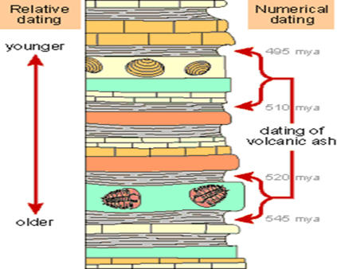
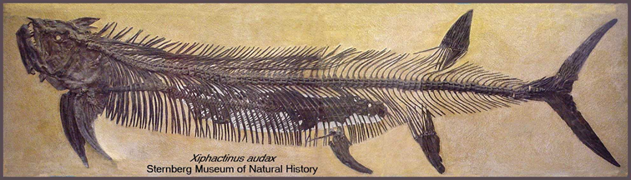

Anatomical Evidence
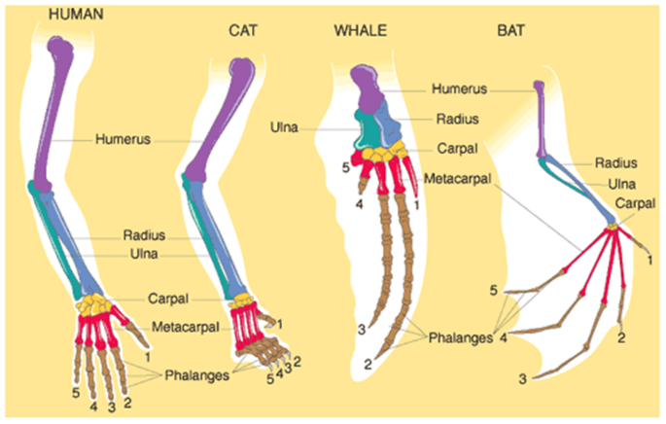

Homologous Structures _________________________________________________________________ __________________________________________________________________________________________________________________________________________________________________________

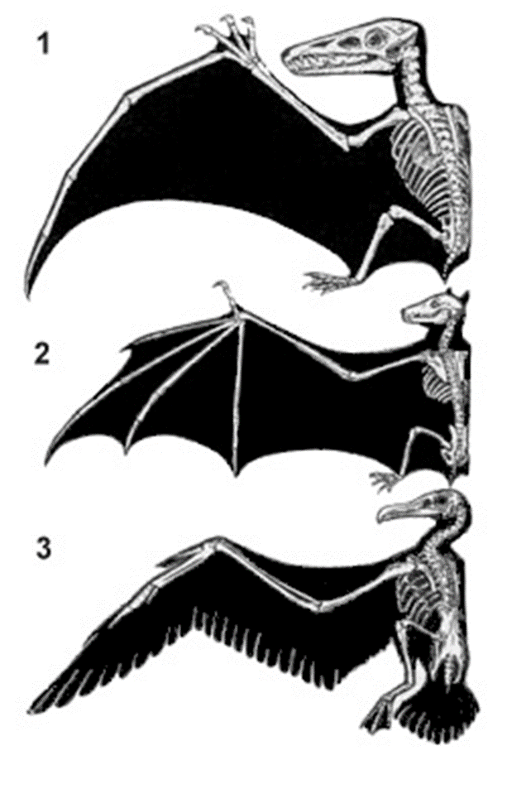
Analogous Structures ___________________________________________________________________ __________________________________________________________________________________________________________________________________________________________________________
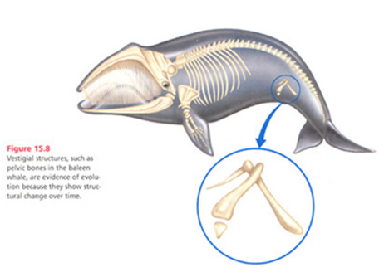
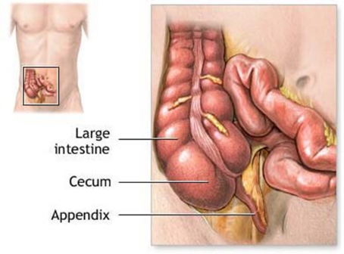
Vestigial Structures ____________________________________________________________________________________ __________________________________________________________________________________________________________________________________________________________________________

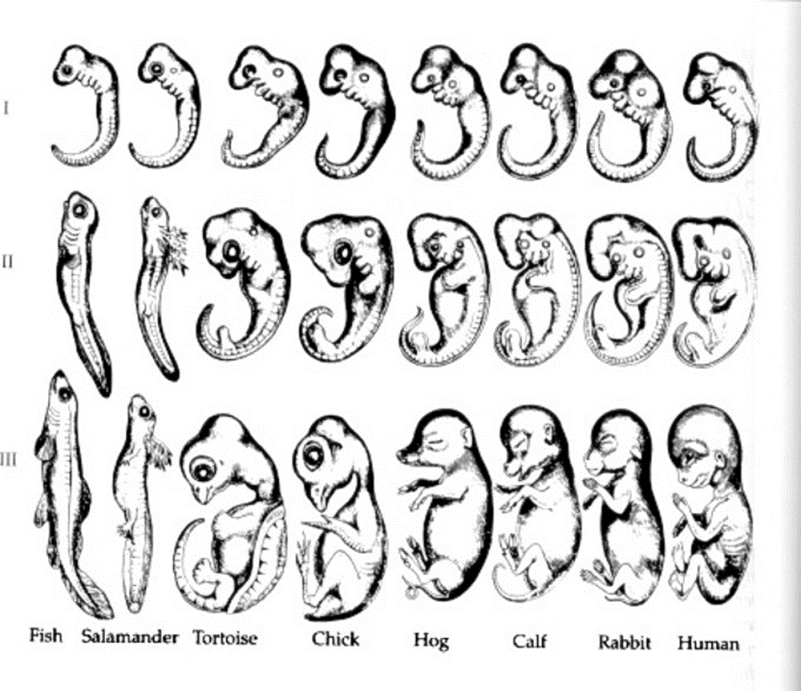
Embryological____________________________________________________________________________________________________________________________________________________________________________________________________________________________________________

Biochemistry __________________________________________________________________ __________________________________________________________________________________________________________________________________________________________________________
