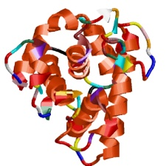
Notes Organizer for Power Point Presentation Proteins and Enzymes
Honors and STEM
Proteins have a wide variety of uses:
- Structure (________________)
- Muscle ___________________________ (muscle fiber structures)
- Transportation (_________________________ carries ___)
- Immunity (___________________)
- Carrying out chemical reactions (____________________, ________________… more to come!)
Proteins are made of:

- _________________
- _________________
- _________________
- _________________
- And sometimes ________________

Proteins have monomers too…
Remember:
Carbohydrates are made up of monosaccharides
Nucleic Acids are made up of nucleotides.
- Proteins are made of ___________ ______________.
Amino Acids
There are _____ amino acids.
Each amino acid is unique, just like the letters in the alphabet are unique.
The ___________ of amino acids in the proteins determines what that protein will do.
Draw an Amino Acid. Use “R” to denote where each amino acid would be different.

Amino Acids are strung together using a chemical reaction known as a “_________________ _________________”
One amino acid loses a ___________________.
The other amino acid loses a hydrogen and an ________________.
2 H + 1 O = water (H₂O)
- Amino acids joined by a ______________ bond form a __________________ chain.
- Amino acids interact, and this determines the __________ of the protein.
This can vary greatly.
__________ varies, too, depending on the ___________ of the amino acid chain!
The shape of the protein allows the protein to perform certain functions.
If the shape of the protein changes, the protein can no longer do its job.
Protein Structure:
- ________________Structure: sequence of amino acids
- ________________Structure: Coils or folds in the polypeptide chain
- ________________Structure: Results from interactions between the “R” groups
- ________________Structure: Overall structure resulting from a protein that is made up of 2 or more chains
A very special type of protein… Enzymes:
Are used to change how _________________ a chemical reaction will happen
This is why they are called “__________________”.
Enzymes fit their _____________________ like a lock fits a _____________.
Enzymes work at different rates depending on

  - ______________________
  - ______________________
  - ______________________ of the substrate
  - environmental factors.

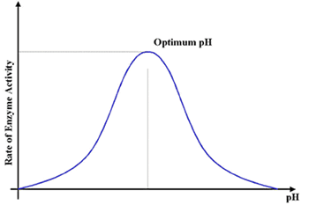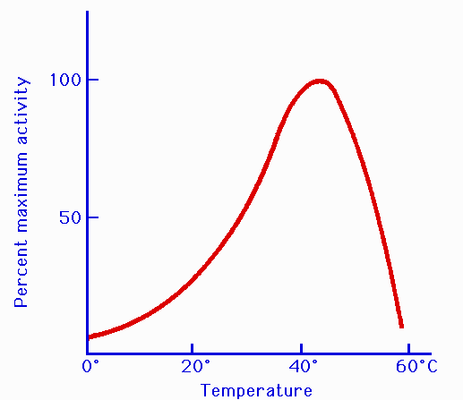
Enzymes will work faster if there is more substrate to work on until….
- There is so much _______________ that there is not enough enzyme to work.
- And vice versa.
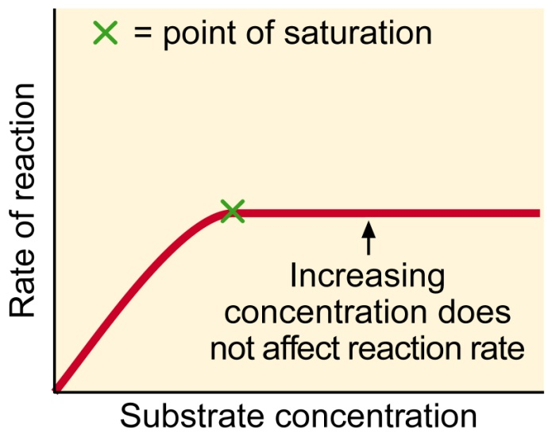
- More enzymes work faster until they _______ _________ of substrate.
- Enzymes are _____________________!
- When an enzyme is done with one piece of substrate, it moves on to the next one…
- And the next one… And the next one… Until the job is done.

