Mendelian Genetics Name________________

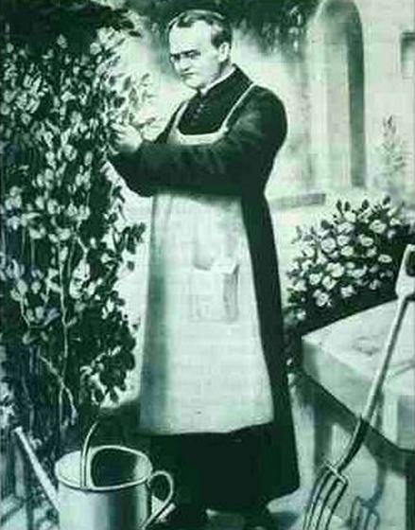
Gregor Mendel (1822-1884) – Responsible for the Laws governing the
_______________ of ________________________________.
- Austrian monk
- Studied the __________________________ of traits in ____________________________.
- Developed the ____________________________________________.
- Mende’s work was not recognized until the turn of the ______________________________________.
- Between _____________________________, Mendel cultivated and tested some __________________________________.
- He found that the plants' offspring retained _____________________________________.
- Called the “________________________________________”.

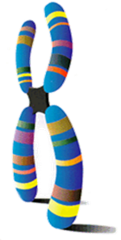
Particulate Inheritance
Mendel stated that physical traits are inherited as ____________________.
Mendel did not know that the “particles” were ____________________________________________________.
Genetics Terminology
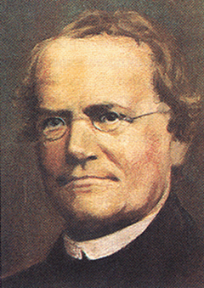
________________ - Any characteristic that can be passed from parent to offspring.
_________________ - Passing of traits from parent to offspring
_________________ - Study of heredity
_______________________ - Cross involving a single trait
_________________ - two forms of a gene (dominant and recessive)
_________________ - stronger of two genes expressed in the hybrid; represented by a __________________.
__________________- gene that shows up less often in a cross; represented by _________________.
More Terminology
___________________ - gene combination for a trait (Examples: ______, ______, ______ )
___________________ - the physical features resulting from a genotype (Examples: _________, __________)
__________________________________ - gene combination involving 2 dominant or 2 recessive genes.
- ___________________________ has a genotype of two capital letters, _________.
- ___________________________ has a genotype of two lowercase letters _________.
________________________________- gene combination with one dominant allele and one recessive allele.
- Example _______ - This is also called a _____________________.
______________________________ - A tool used to help solve genetic problems.
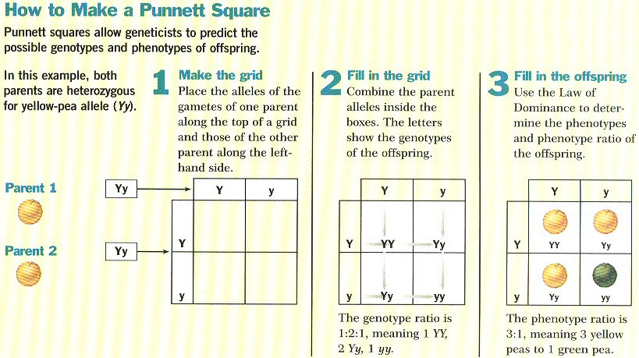

Eight Pea Plant Traits

Seed shape --- Round (R) or Wrinkled (r)
Seed Color ---- Yellow (Y) or Green (y)
Pod Shape --- Smooth (S) or wrinkled (s)
Pod Color --- Green (G) or Yellow (g)
Seed Coat Color ---Gray (G) or White (g)
Flower position---Axial (A) or Terminal (a)
Plant Height --- Tall (T) or Short (t)
Flower color --- Purple (P) or white (p)

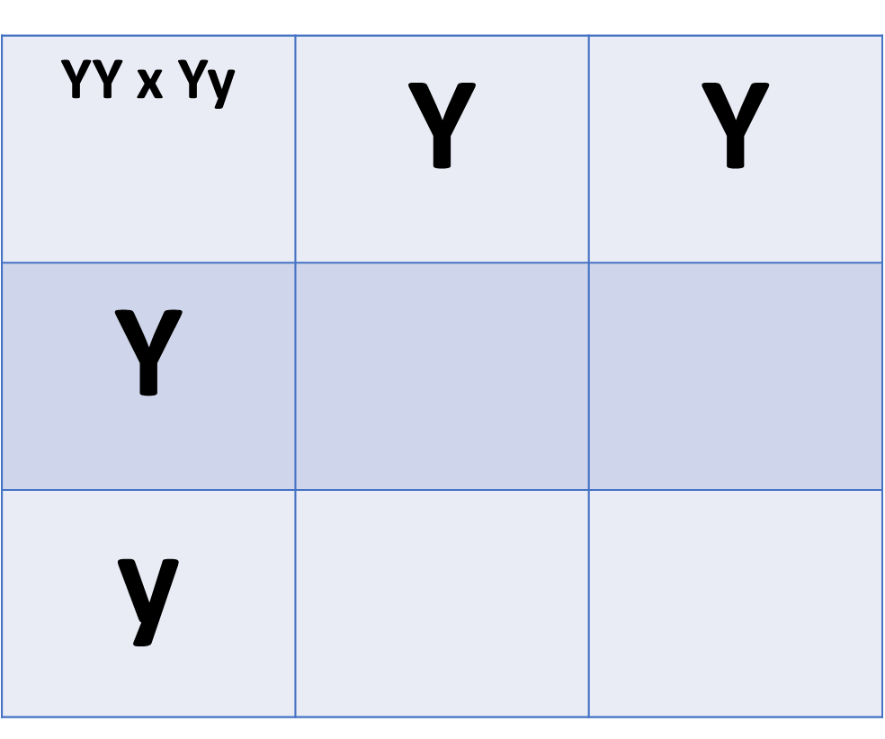
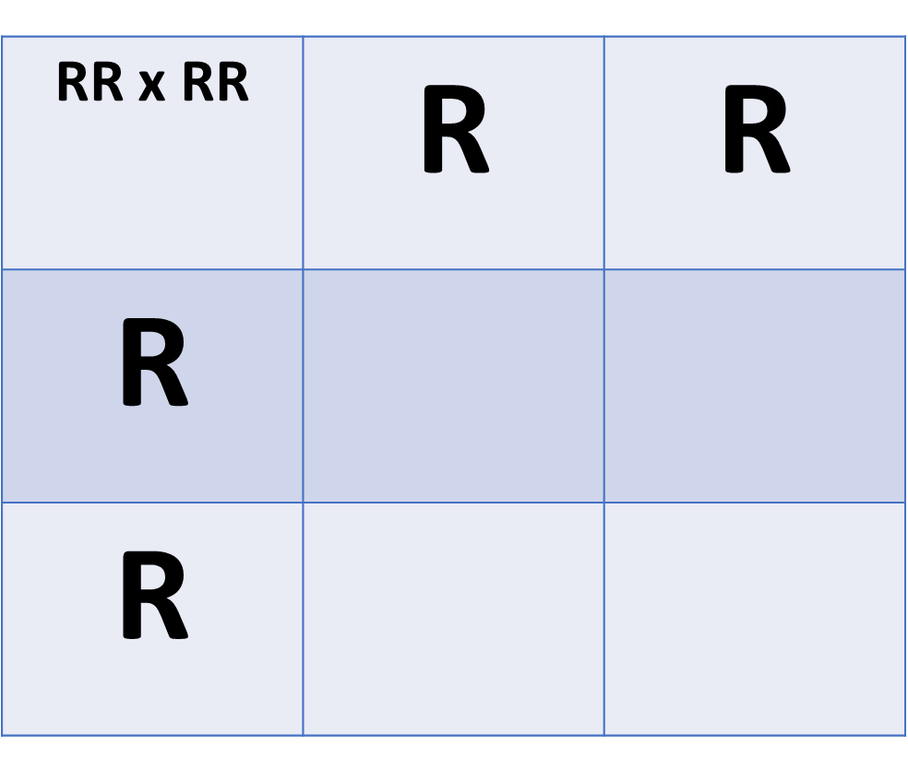
Punnett Square: The Six Possible Monohybrid Crosses

