Plasma Membrane (Honors-STEM)
(Aka ______ Membrane)
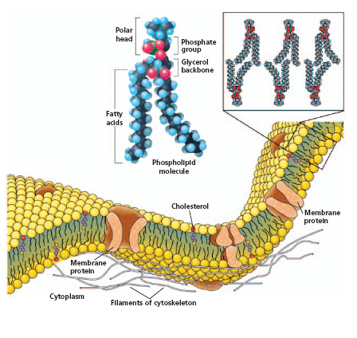
What is it made of?
- Phospholipids
What are they?
- _________________ ___________ heads
- _________________ ________________ fatty acid tails
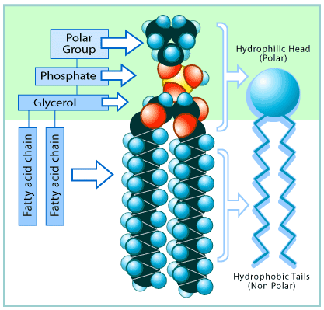
The lipids are arranged in a special way
- A ________________: 2 layers
- Bilayers are sort of like a sandwich
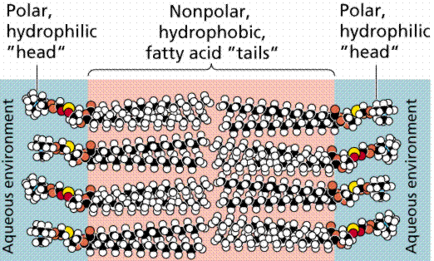
Top Layer
Bottom Layer

Water is a key component of cells too!
- Both ____________ and ____________ of the cell
- The _________ phospholipid heads allow ___________ to pass through freely
  - It doesn’t repel it!!
- However, the _______________ tails keep the other stuff that is dissolved in the ___________ from passing through the membrane.
- The plasma membrane is ____________________________
  - This means that it can select what goes through it!
  - Kind of like the _____________ in your back door!
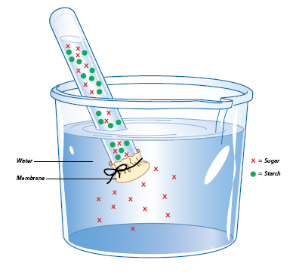
- What types of molecules enter and exit a cell?
  - _______________ in
  - Amino acids in
  - Waste out
  - ______________ out
  - Water in/out
  - ______________ in
Other important stuff found in the plasma membrane
- _________________________- stabilizes fatty acids
- _________________________- for transporting large molecules across the membrane, others help attach to internal support structure
- _________________________- help with identifying chemical signals and other cells
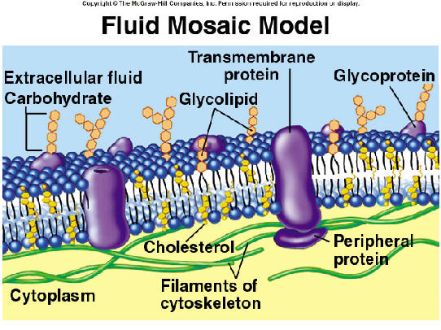
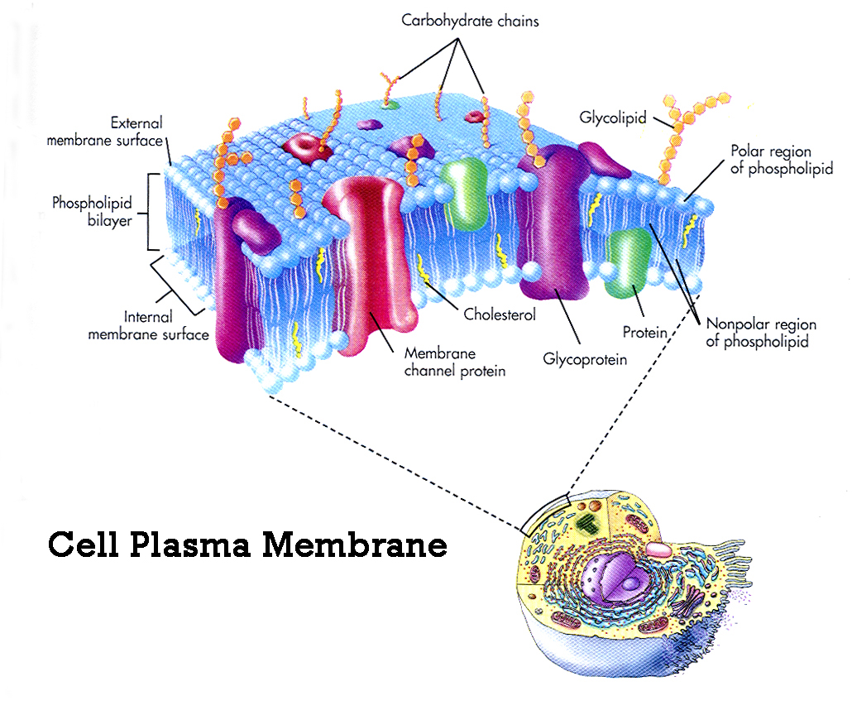
What other names, if any, are used for the following in this diagram?
Phospholipids-
Cholesterol-
Carbohydrates-
Membrane Protein

