Intro to Sustainability – Notes Organizer Name __________________________

Sustainability - ________________________________________________________________
____________________________________________________________________________
___________________________________________________________________________________

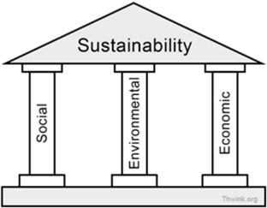
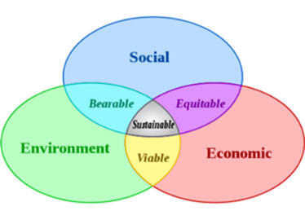
3 Pillars of Sustainability

Environmental Sustainability
- Environmental sustainability is _________________________________________
__________________________________________________________________
_________________________________________________________________.
- This is the world's biggest actual problem, though since the consequences of not solving the problem now are delayed, the problem receives too low a priority to solve.

Ways to Ensure Environmental Sustainability
- For renewable resources, the ____________________________ should not exceed the __________________________________.
- [For pollution] The rates of ________________________________ from projects should not exceed the ________________________________________________ (sustainable waste disposal).
- For nonrenewable resources the __________________________________ should require comparable development of _____________________________ for that resource.
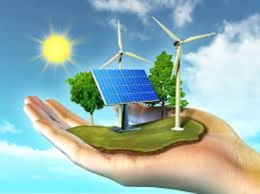

Social Sustainability
- Social Sustainability is the ability of a social system, such as a country, family, or organization, _______________________________________________________
__________________________________________________________________
- Problems like war, endemic poverty, widespread injustice, and low education rates are symptoms a system is socially unsustainable.

Ways to Ensure Social Sustainability
- There is a universal disagreement on what quality of life goals should be. Not only do nations disagree. So do their political parties, their religions, their cultures, their classes, their activists organizations, and so on. Therefore, ______________
___________________________________________________________________________________________________.
- Social Sustainability is the ________________________________ of them all because people can't even agree on which way is up.
Economic Sustainability
- Economic sustainability is the ability of __________________________________
__________________________________________________________________
______________________________________.
- Since the Great Recession of 2008 this is the world's biggest apparent problem, which endangers progress on the environmental sustainability problem.
Ways to Ensure Economic Sustainability
- To be economically sustainable, an organization/business/ country must be profitable.
- This task is way easier said than done, but having success in both environmental and social sustainability greatly enhance economic sustainability.
Global Sustainability Issues
Social Environmental Economic

