Transcription and Translation
Using directions from ___________ to synthesize ______________
- Why do we need protein? _____________________________________________________
- Where do we get protein? _____________________________________________________
- We break these proteins down to their monomers (____________________) and make proteins that we need.
- Transcription
  - Occurs in the __________________
  - Process that uses the directions in __________ to make _____________
  - ________________________ unzip in short segments
  - RNA Nucleotides are free floating in the nucleus
  - They form a complementary strand of ____________ to the DNA
  - DNA ___________ back up.
  - Not all mRNA gives actual directions
  - ________- Intervening regions
    - Non-Coding (JUNK)
  - ________- Expressed regions
    - Coding regions
    - They mean something!
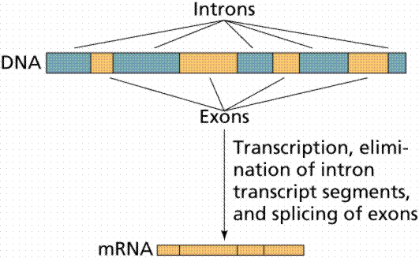
  - After removing _________________, the mRNA moves into the ______________ where translation occurs!
- Steps in Translation
- 1st: ______________ binds to _____________
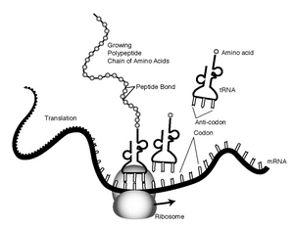

- 2nd: ______________ instructs ____________ to bring the appropriate Amino Acid
- rRNA knows which amino acids to tell tRNA to bring because of _____________ that are found on _________
- The ________________ on tRNA complements the ___________ on the mRNA
- Page 292 in your text can be used to see the mRNA genetic code and names of the amino acids
- The amino acids bond together to form _________________________ = Proteins
