Types of Body Movements

Flexion

Decreases the angle of the joint

Brings two bones closer together

Typical of bending hinge joints like knee and elbow or ball-and-socket joints like the hip
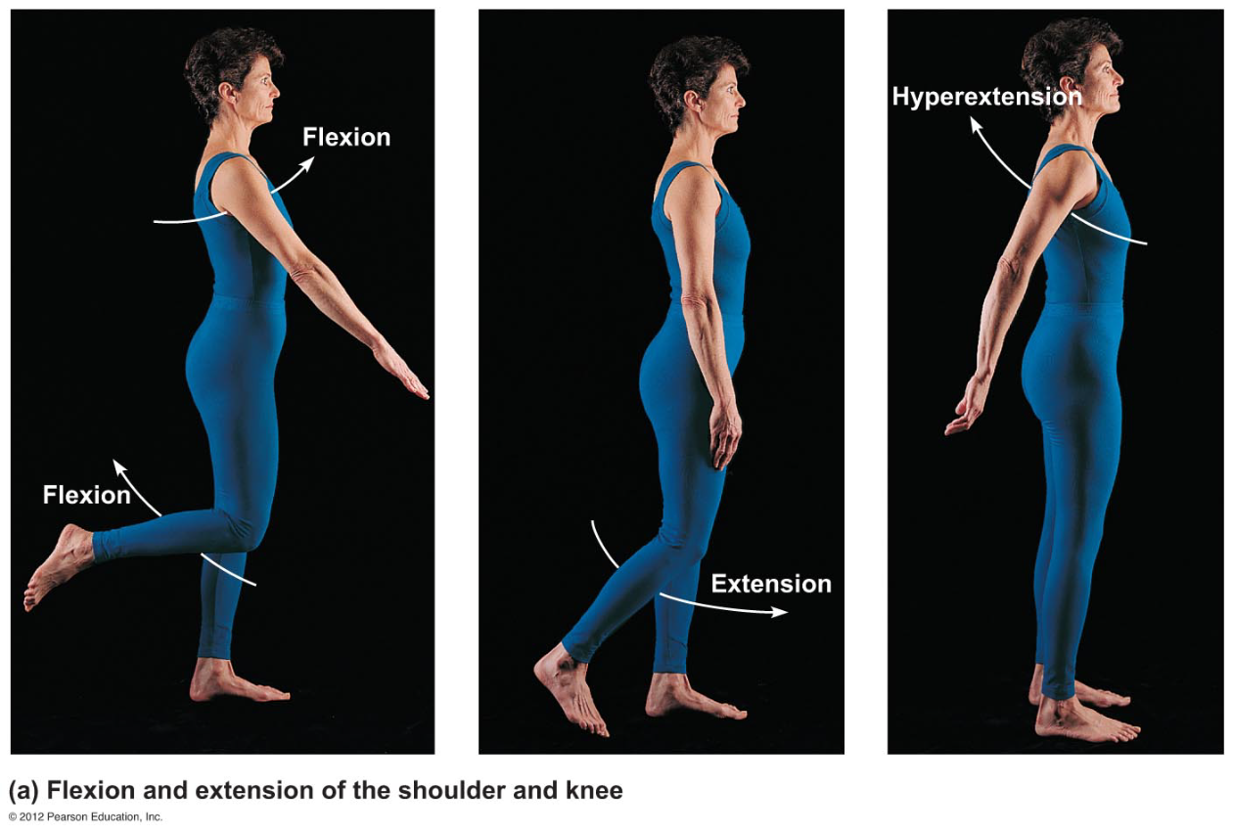

Extension

Opposite of flexion

Increases angle between two bones

Typical of straightening the elbow or knee

Extension beyond 180° is hypertension

Rotation

Movement of a bone around its _________________axis

Common in ball-and-socket joints

Example is when you move atlas around
the dens of axis (shake your head “no”)

Abduction

Movement of a limb _________________from the midline

Adduction
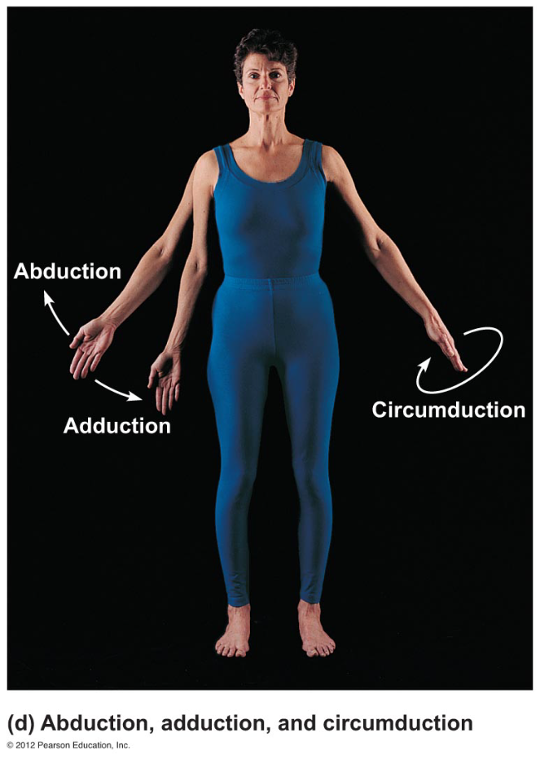

Opposite of abduction
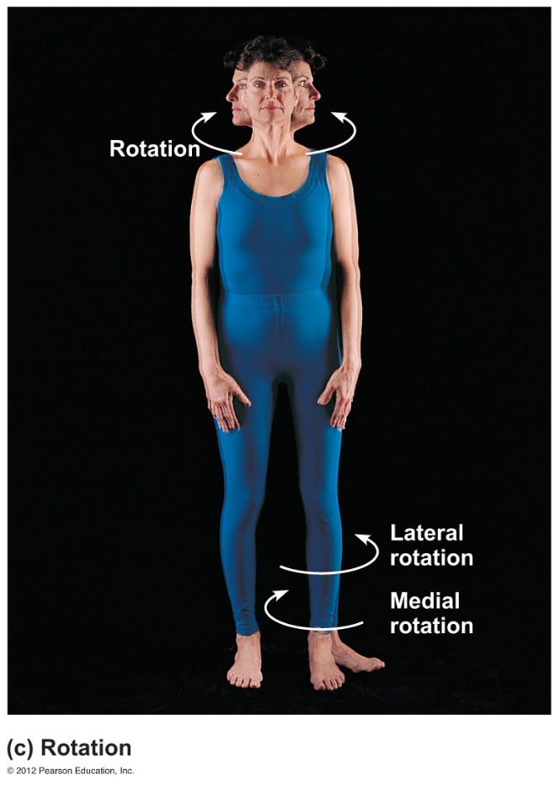

Movement of a limb _________________the midline

Circumduction

Combination of flexion, extension, abduction, and adduction

Common in ball-and-socket joints

Special Movements

Dorsiflexion

Lifting the foot so that the superior surface _________________the shin (toward the dorsum)

Plantar flexion

Depressing the foot (_________________the toes)

“Planting” the foot toward the sole

Inversion

Turn sole of foot _________________
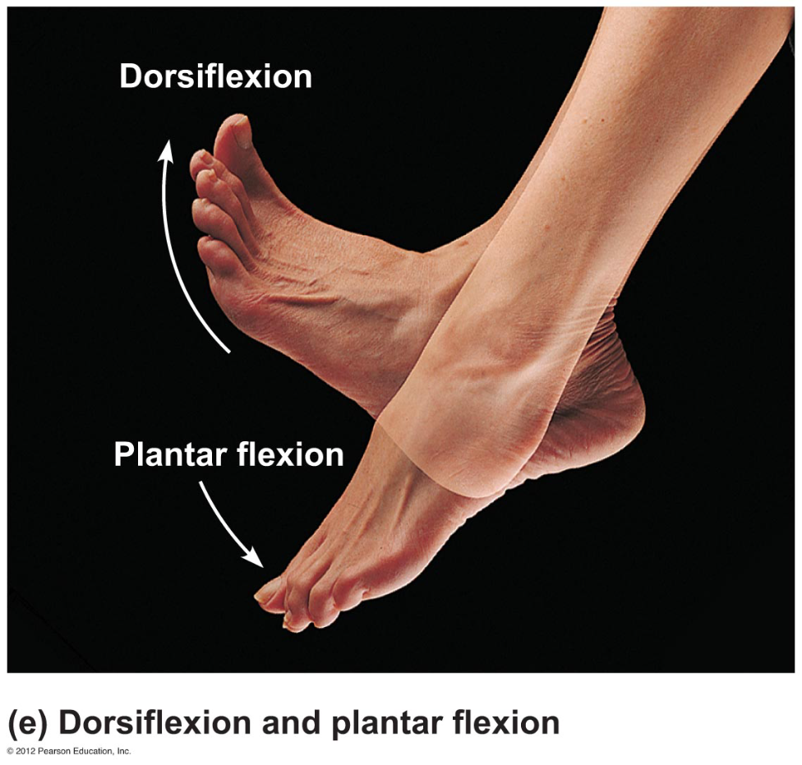
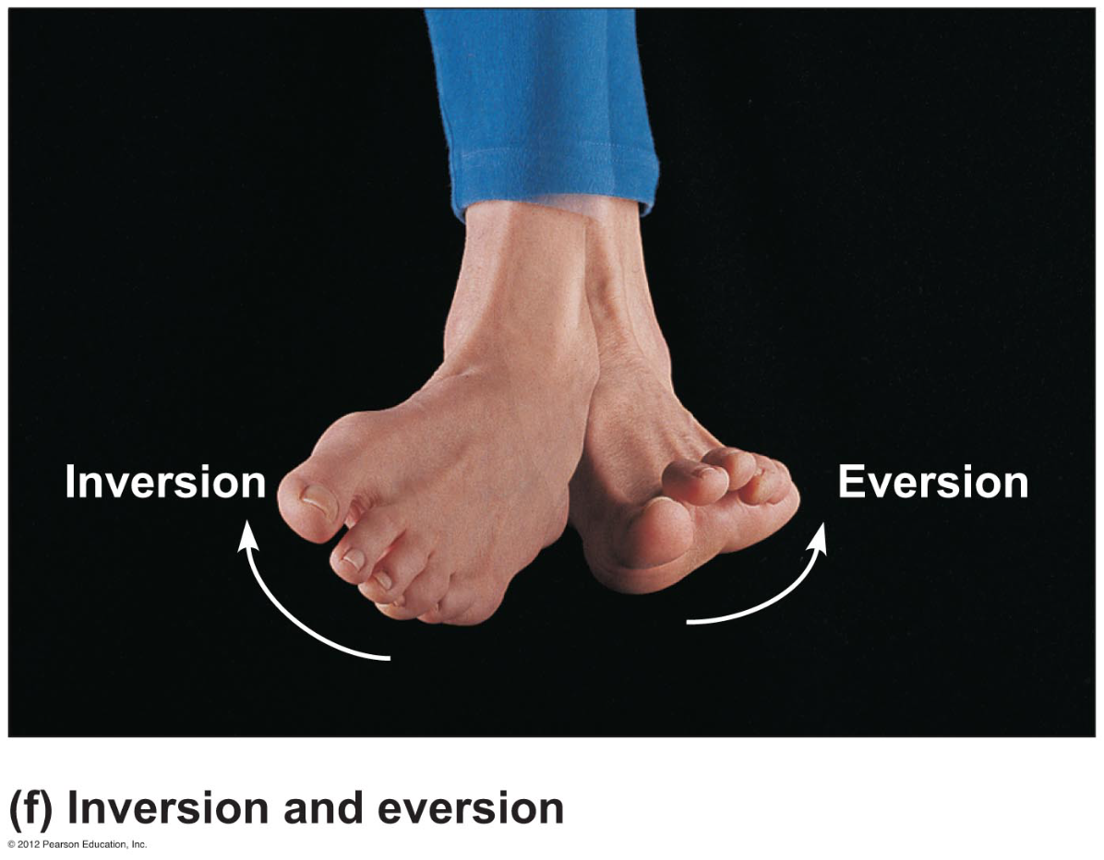

Eversion

Turn sole of foot _________________

Supination

Forearm rotates laterally so palm faces anteriorly
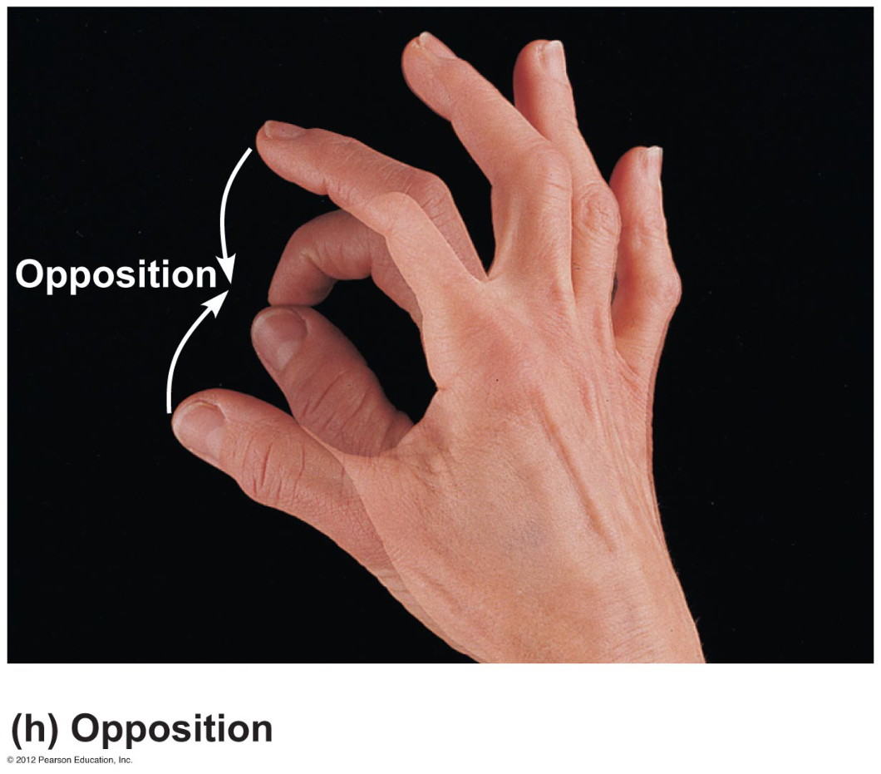
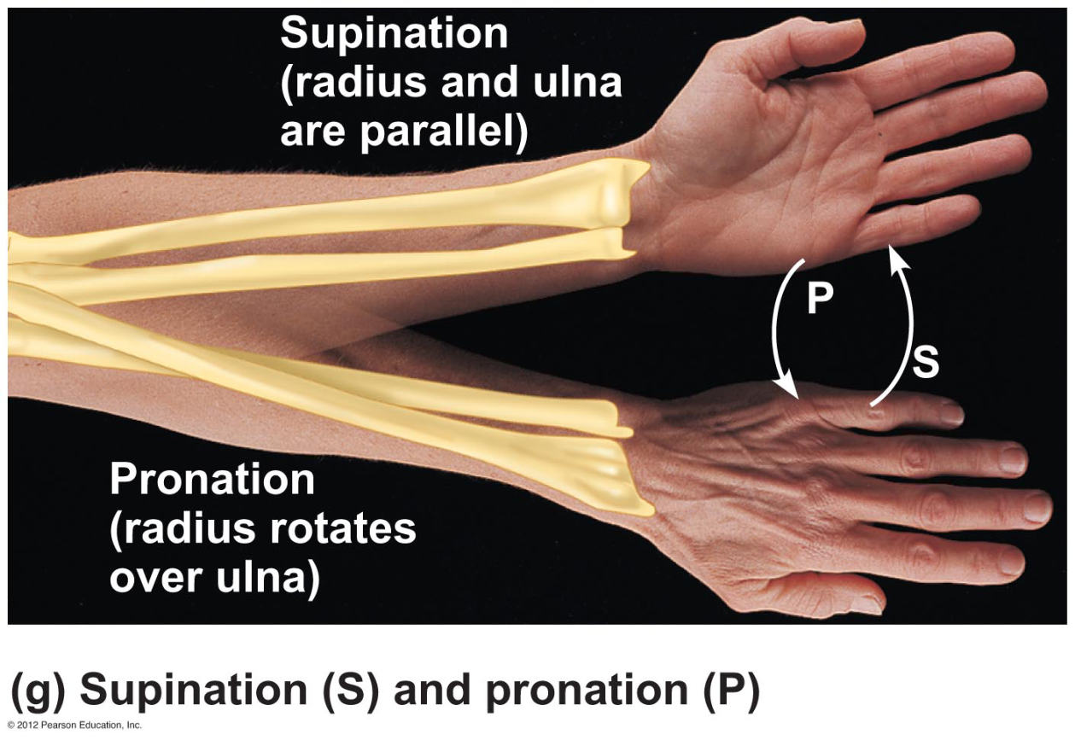

Radius and ulna are _________________

Pronation

Forearm rotates medially so palm faces posteriorly

Radius and ulna _________________each other like an X

Opposition

Move thumb to _________________the tips of other fingers on the same hand

