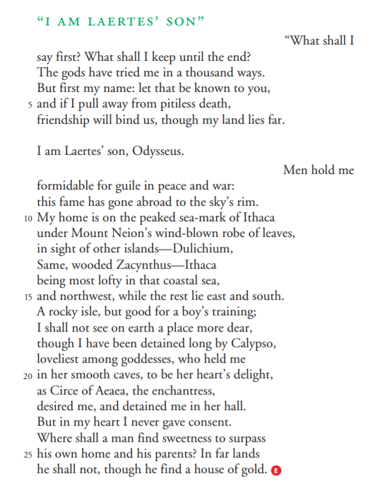

**Close Reading Passage #1**

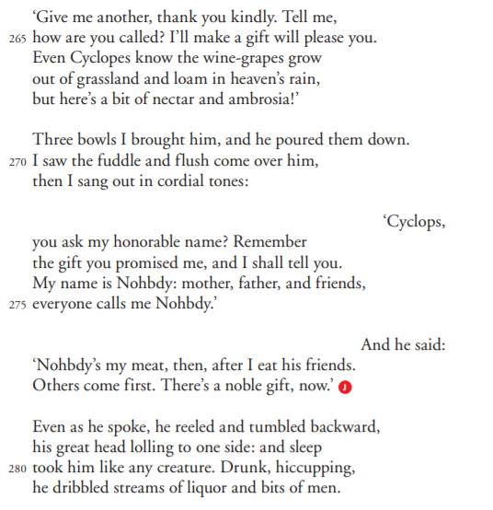

**Close Reading Passage #2**

**Close Reading Passage #3**