Environmental Science
Oreo Cookie Activity
Theory of Plate tectonics
The theory of plate tectonics states that the lithosphere is made up of plates that move. This theory also explains why and how earthquakes and volcanoes are likely to occur within certain areas as well as how new crust forms along the ocean floor. These plates are thought to float across the top of the asthenosphere. The asthenosphere is the layer just below the lithosphere. While in motion the plates interact with each other at their boundaries. The interactions at the boundaries of the plates, refers to how the plates interact at their edges. Plates interact with one in other in several ways. The main types of interactions are convergent, divergent and transform boundaries. Use Oreos for to demonstrate a sliding plate over the asthenosphere and the following types of boundaries.
Oreo 1: Sliding Plate over Asthenosphere
Directions:
- Carefully without breaking the cookie remove the top cookie.
- Then slide this top portion of the cookie over the filling.
- Once completed place your cookie on your portion of your napkin marked sliding over asthenosphere.
This represents the movement of a plate sliding over the asthenosphere.
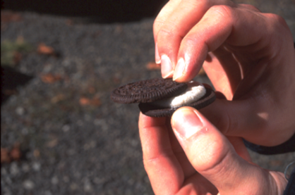
During plate movement plates interact in varies ways. The plates may move toward one another, converge or collide. Other options of plate movement include them pulling apart from one another, or sliding alongside each other. The movements of the plates are referred to as their plate boundaries. The types of plate boundaries are classified according to their movement. Again as stated above, the following are the most common plate boundaries: convergent, divergent and transform.
Oreo 2: Convergent plate boundary
With convergent plate boundaries the plates are moving toward each other or converging. There are two types of convergent plate boundaries: subduction and collision boundaries. Subduction boundaries occur when an oceanic plate goes beneath another plate (subducting). These can occur when two oceanic plates or when an oceanic plate and a continental plate converge. When two oceanic plates converge they form a deep-sea trench, which followed by the formation of a chain of volcanic islands. Example includes the Mariana Trench that has created the volcanic Mariana Islands.
When oceanic plates converge with continental plates the denser oceanic plate subducts beneath the continental plate. A deep sea trench is formed, and then a mountain chain and volcano may form.
Collision boundaries are also considered convergent boundaries. These boundaries occur when two converging plates carry continents. These two continents generally become glued together, creating one larger continent. This collision generally will cause one plate to be pushed upward into a mountain range. An example of such an event created the Himalaya Mountains. For more details refer to pages 176-179 in Littell’s Earth Science.
Directions:
- Carefully break the top cookie of your Oreo in half. (Do not break the bottom cookie)
- Then bring the broken parts together in the center of the Oreo.
- Once completed place your cookie on your portion of your napkin marked divergent boundary.
This represents a convergent boundary.
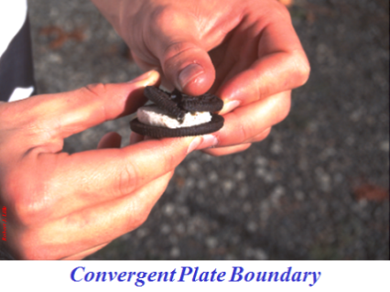
Oreo 3: Divergent Plate boundaries
When two lithospheric plates move away from each other they are considered to be a divergent boundary. Divergent boundaries sometimes referred to as “spreading centers,” occur during sea-floor spreading. An example would include the Mid-Atlantic Ridge. For more details refer to pages 176-179 in Littell’s Earth Science.
Directions:
- Carefully break the top cookie of your Oreo in half. (Do not break the bottom cookie)
- Then pull the two parts of the top cookie apart.
- Once completed place your cookie on your portion of your napkin marked divergent boundary.
This represents a divergent boundary.
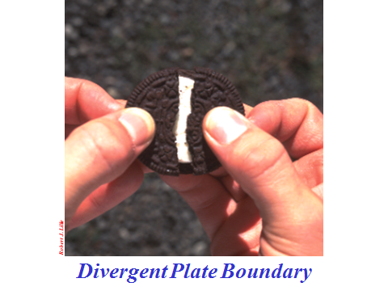
Oreo 4: Transform Plate boundary
Transform boundaries are when two plates slide past one another. With transform boundaries the movement of the plates is not equal. An example of a transform boundary is in California. This occurs where the North American plate passes along the Pacific Plate, along the San Andreas Fault. During this movement the Pacific Plate is moving Northwest and the North American Plates is moving southwest. Portions of the San Andreas Fault move as much as five centimeters per year, whereas in other sections it has not moved in over a century.
Directions:
- Carefully break the top cookie of your Oreo in half. (Do not break the bottom cookie)
- Then pull the two parts of the top cookie pass one another, in opposite directions.
- Once completed place your cookie on your portion of your napkin marked transform boundary.
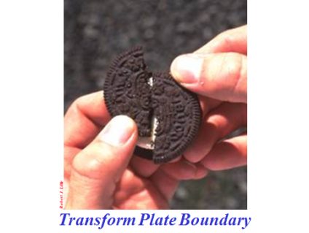
Questions:
- What are differences between convergent, divergent and transform boundaries? What are their similarities?

- How many different types of convergent boundaries are there? What are they called and what are their characteristics?

- What occurs when there is a transform boundary?

- What types of boundaries create mid-ocean ridges?

- Which types create mountains? Explain each situation and give an example.

- Which types of plate boundaries do you think can cause earthquakes? Explain the reasoning to your answer/s.

