Organelles

Organelles

Defines structures found in most eukaryotic cells.
http://www.ck12.org/life-science/Organelles-in-Life-Science/lesson/Organelles/

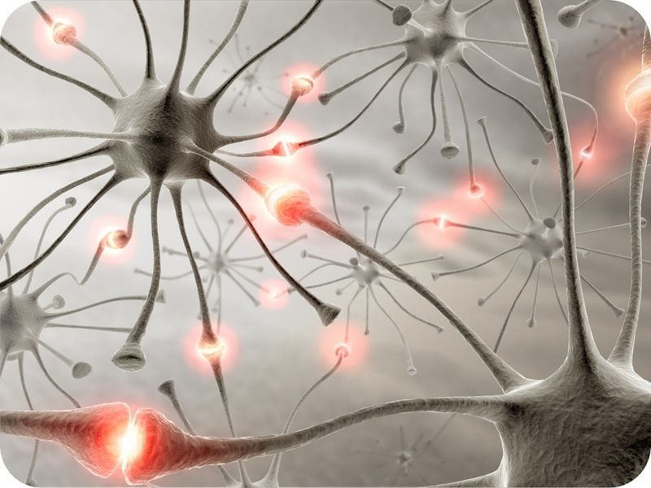
Do brain cells have the same internal structures as your other cells?
Yes. Although brain cells look quite different from your other cells, they have the same internal structures as other cells. They need the same structures because they need to perform the same tasks, such as making proteins and obtaining energy.

Organelles
Eukaryotic cells have many specific functions, so it can be said that a cell is like a factory. A factory has many machines and people, and each has a specific role. Just like a factory, the cell is made up of many different parts. Each part has a special role. The different parts of the cell are called organelles, which means "small organs." All organelles are found in eukaryotic cells. Prokaryotic cells are "simpler" than eukaryotic cells. Though prokaryotic cells still have many functions, they are not as specialized as eukaryotic cells, lacking membrane-bound organelles. Thus, most organelles are not found in prokaryotic cells.
Below are the main organelles found in eukaryotic cells (Figure below):
- The nucleus of a cell is like a safe containing the factory's trade secrets. The nucleus contains the genetic material (DNA), the information needed to build thousands of proteins.
- The mitochondria are the powerhouses of the cell. Mitochondria are the organelles where cellular energy is produced, providing the energy needed to power chemical reactions. This process, known as cellular respiration, produces energy is in the form of ATP (adenosine triphosphate). Cells that use a lot of energy may have thousands of mitochondria.
- Vesicles are small membrane bound sacs that transport materials around the cell and to the cell membrane.
- The vacuoles are like storage centers. Plant cells have larger vacuoles than animal cells. Plants store water and nutrients in their large central vacuoles.
- Lysosomes are like the recycling trucks that carry waste away from the factory. Lysosomes have digestive enzymes that break down old molecules into parts that can be recycled.
- In both eukaryotes and prokaryotes, ribosomes are the non-membrane bound organelles where proteins are made. Ribosomes are like the machines in the factory that produce the factory's main product. Proteins are the main product of the cell.
- Some ribosomes can be found on folded membranes called the endoplasmic reticulum (ER), others float freely in the cytoplasm. If the ER is covered with ribosomes, it looks bumpy like sandpaper, and is called the rough endoplasmic reticulum. If the ER does not contain ribosomes, it is smooth and called the smooth endoplasmic reticulum. Many proteins are made on the ribosomes on the rough ER. These proteins immediately enter the ER, where they are modified, packaged into vesicles and sent to the Golgi apparatus. Lipids are made in the smooth ER.
- The Golgi apparatus works like a mail room. The Golgi apparatus receives proteins from the rough ER and puts "shipping addresses" on them. The Golgi then packages the proteins into vesicles and sends them to the right place in the cell or to the cell membrane. Some of these proteins are secreted from the cell (they exit the cell); others are placed into the cell membrane.
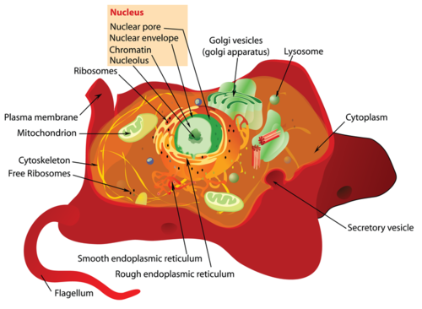

Eukaryotic cells contain special compartments surrounded by membranes, called organelles. For example, notice in this image the mitochondria, lysosomes, and Golgi apparatus.
Also, the cytoskeleton gives the cell its shape, and the flagella helps the cell to move. Prokaryotic cells may also have flagella.

