PANAMA CANAL

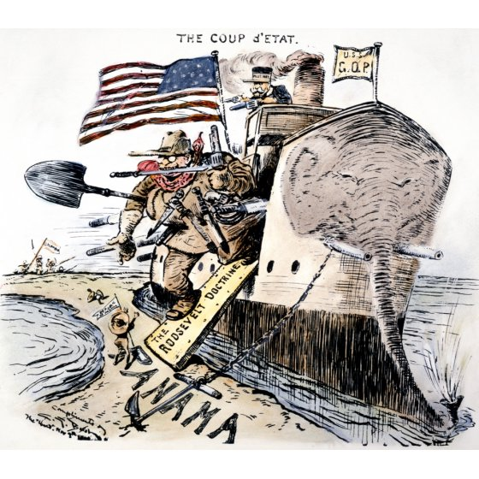

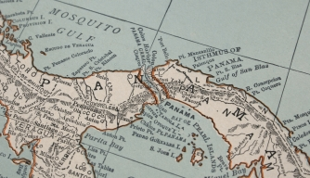

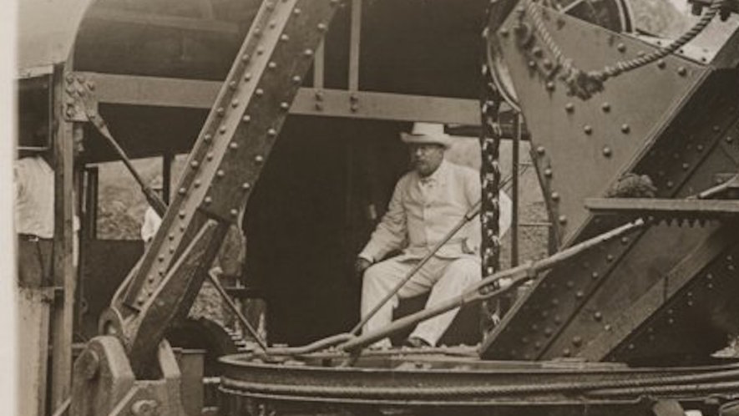

STIMULUS BASED QUESTIONS

Stimulus 1
Image of Panama
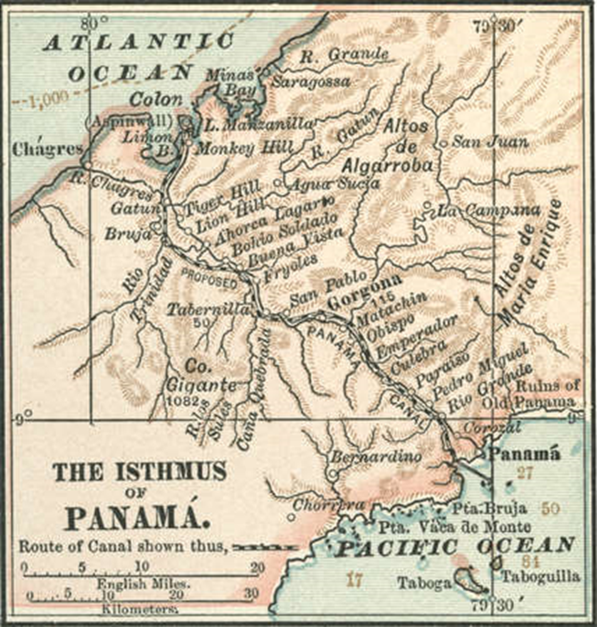

- Why would constructing the canal be beneficial to the United States?
_________________________________________________________________________________
_________________________________________________________________________________
_________________________________________________________________________________

- Explain how the Panama Canal is related to American imperialistic goals, and foreign policy during the early 20th century.
_________________________________________________________________________________
_________________________________________________________________________________
_________________________________________________________________________________
Stimuli Two
Theodore Roosevelt Quotes

Once in office, Teddy Roosevelt moved quickly, and in 1903 a treaty was arranged with Colombia. The treaty provided the United States pay 10 million dollars to Colombia plus an annual rental fee of 250,000 dollars in exchange for leasing a ten-mile wide canal zone across the province of Panama.
Roosevelt, who was eager to “make the dirt fly,” was surprised and furious when the Colombian Congress refused to accept the treaty. In anger, Roosevelt referred to the leaders of Colombia as “Homicidal Corruptionists” and added that “you could no more make an agreement with the Colombian rulers than you could nail currant jelly to a wall.”
Then in the fall of 1903, a revolution took place in Panama. Revolutionists in the province of Panama declared their independence from Colombia and formed a new country which they called the Republic of Panama. Within days the new nation signed a canal treaty with the United States on the same terms which Colombia had refused. Panama had gained its independence, and Theodore Roosevelt now had his chance to start on the canal.

- Identify why the Unites States would act quickly and offer a lucrative deal too Colombia.
_________________________________________________________________________________
_________________________________________________________________________________
_________________________________________________________________________________

- Explain how Roosevelt viewed the Colombian leaders, use evidence from the passage above to support your answer.
_________________________________________________________________________________
_________________________________________________________________________________
_________________________________________________________________________________

- Why would the Panamanian government need the support of the United States, and why would this be advantageous to Roosevelt?
_________________________________________________________________________________
_________________________________________________________________________________
_________________________________________________________________________________

Stimuli 3
Quote from Theodore Roosevelt – 1914

“People say that I fomented insurrection in Panama prior to the time that I became President. While I was President I kept my foot down on those revolutions so that when the revolution referred to did occur, I did not have to foment it; I simply lifted my foot.”

- Explain what Theodore Roosevelt meant in the passage above.
_________________________________________________________________________________
_________________________________________________________________________________
_________________________________________________________________________________

- What is the significance of Roosevelt’s statement that he “simply lifted my foot?”
_________________________________________________________________________________
_________________________________________________________________________________
_________________________________________________________________________________

Stimuli 4
Letter by José Marroquín, President of Colombia:
The Rights of Colombia – A Protest and Appeal (November 28, 1903)

“The government of the United States is treating Colombia in a manner that seems dishonorable to all the people of that country. American Secretary of State Hay, has astonished the world by finding a right to exclude the troops of Colombia from the Isthmus of Panama.
The United States violated international law by recognizing the independence of Panama only days after the revolution and before the nation of Colombia had a chance to put down the insurrection. Colombia did not recognize the southern states which seceded during the American Civil war – why should the United States recognize the seceding states of Panama?”
- How does the President of Colombia view the Panama Canal? Use evidence from the passage above to support your answer.
_________________________________________________________________________________
_________________________________________________________________________________
_________________________________________________________________________________

- How can the United States be considered hypocritical, and why would the United States act this way?
_________________________________________________________________________________
_________________________________________________________________________________
_________________________________________________________________________________

Stimuli 5
Quote by Theodore Roosevelt

"I naturally take an interest in it because I started it . . . the Panama Canal wouldn’t have been started if I hadn’t taken hold of it. . . . I took a trip to the Isthmus, started the canal and then left Congress not to debate the canal, but to debate me and in portions of the public press the debate still goes on as to whether or not I acted properly in getting the canal but while the debate goes on the canal does too and they are welcome to debate me as long as they wish, provided that we can go on with the canal now."

- Describe the main idea of the passage above.
_________________________________________________________________________________
_________________________________________________________________________________
_________________________________________________________________________________

- Does Roosevelt seem to care about the press? What is his main goal?
_________________________________________________________________________________
_________________________________________________________________________________
_________________________________________________________________________________

Stimuli 6
Theodore and Edith Roosevelt’s Trip to the Canal 1906

The first attempt to build a Panamanian canal by Frenchmen faced numerous obstacles; the rapid and increasing death rate among its workers was the most difficult of all to overcome. Some Americans questioned why the president would go into such a disease-infested region when there was no real need to do so. American construction of the canal was aided by the dramatic reduction in sickness and death among workers wrought by breakthroughs in mosquito control and medical treatment. Roosevelt’s passion for the greatness of America’s Panamanian achievement included his belief that the danger of disease had been conquered satisfactorily to allow his visit.

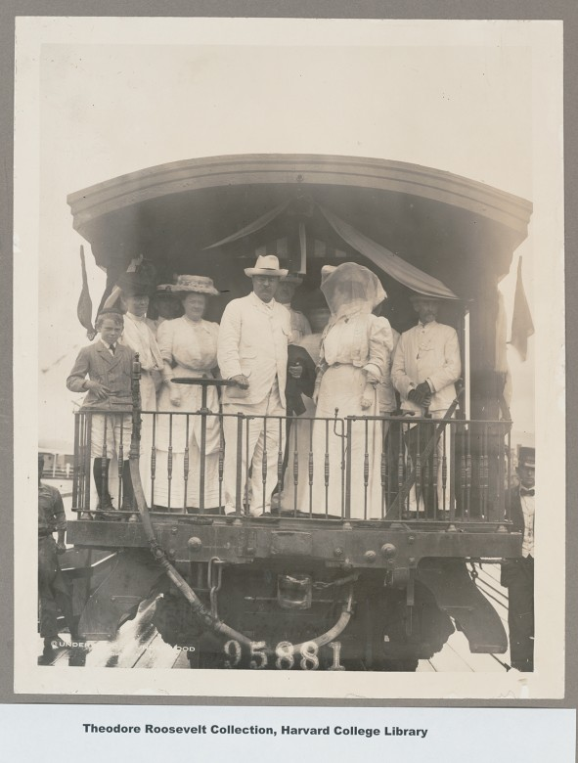

- What was the most difficult obstacle to overcome while building the Panama Canal?
_________________________________________________________________________________
_________________________________________________________________________________
_________________________________________________________________________________

- Explain why the First Lady would be wearing that headdress with nets.
_________________________________________________________________________________
_________________________________________________________________________________
_________________________________________________________________________________

Stimuli 7
Panama Canal Political Cartoon
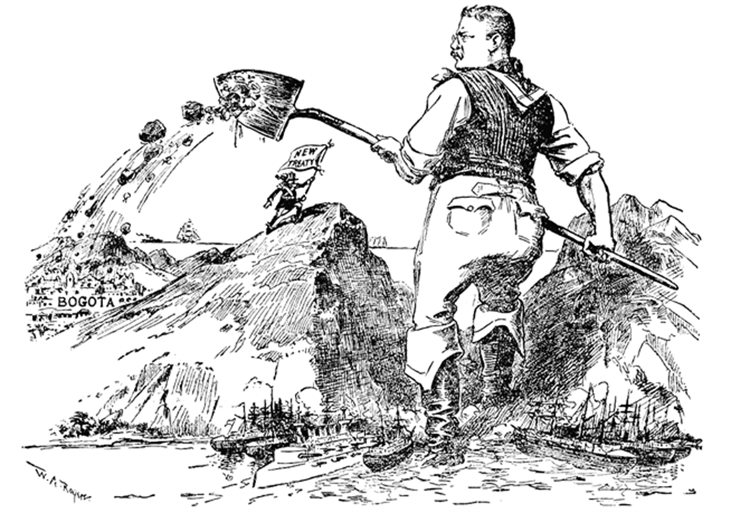

- What does the flag refer to?
_________________________________________________________________________________
_________________________________________________________________________________
_________________________________________________________________________________

- What do the ships in the foreground represent?
_________________________________________________________________________________
_________________________________________________________________________________
_________________________________________________________________________________

- What does the image of Roosevelt dumping dirt on Bogota symbolize?
_________________________________________________________________________________
_________________________________________________________________________________
_________________________________________________________________________________

