Name: ____________________________________________ Date: ______________

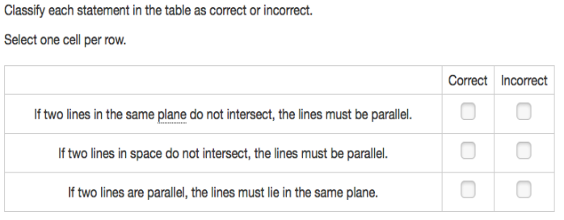PARCC Practice Day 3

2. 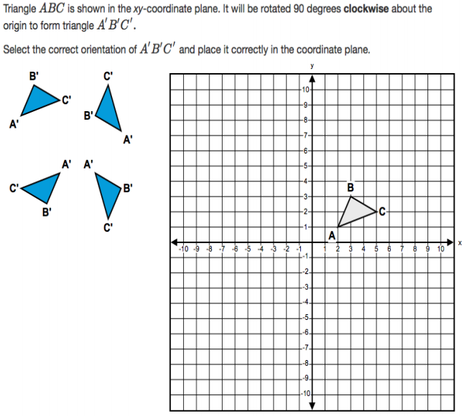
3. 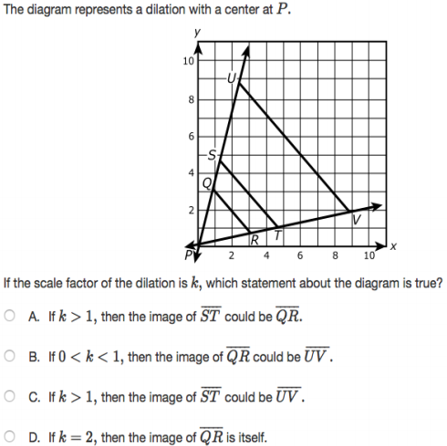

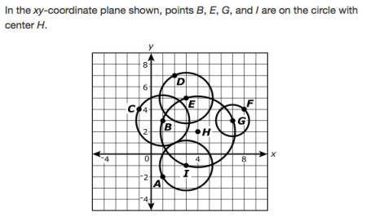



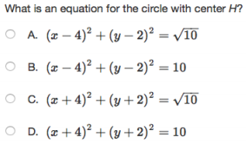

1. 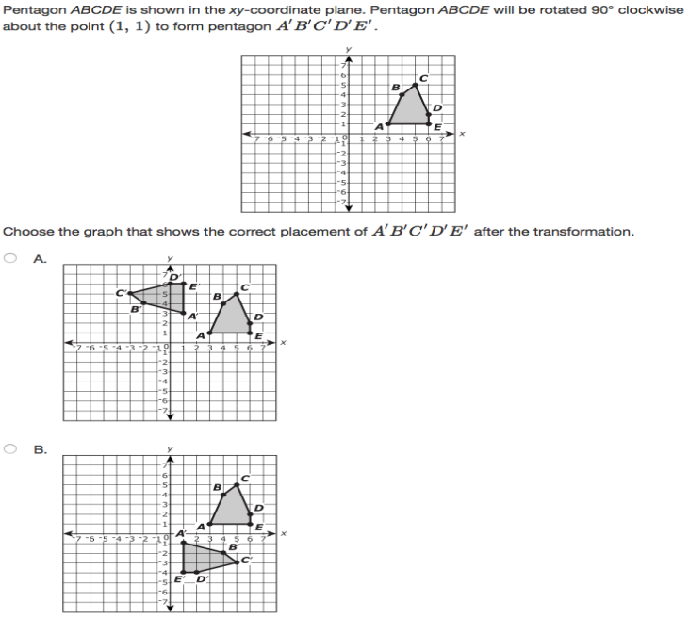

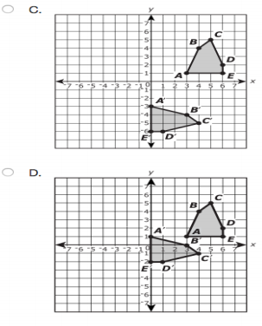

1. 