Name: _____________________________________________________ Date: _______________

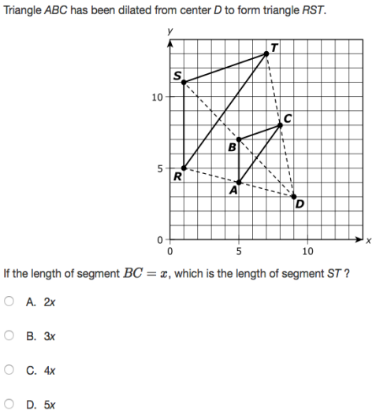PARCC Practice Day 4

2. 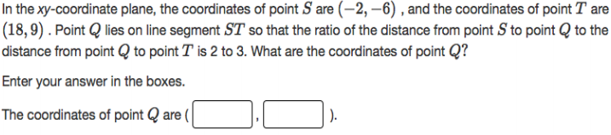
3. 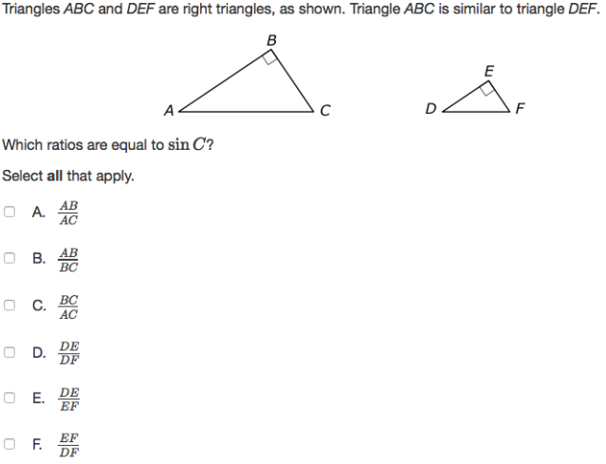

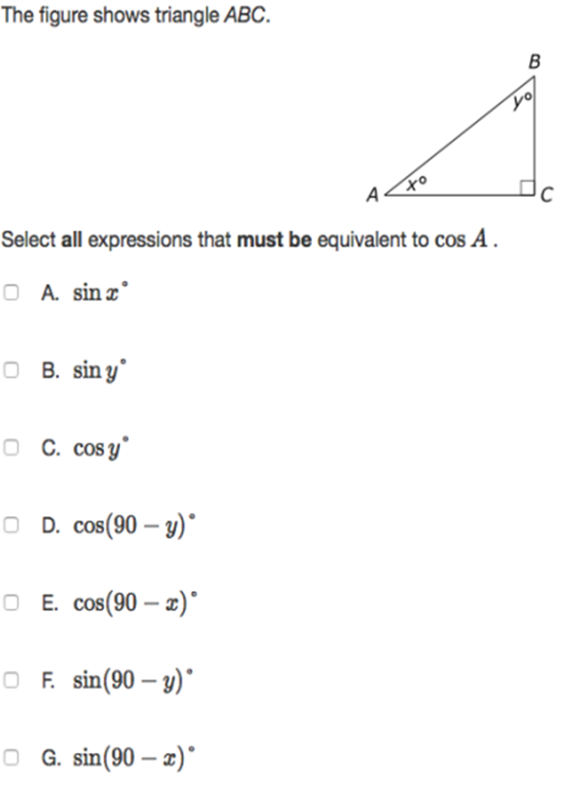

1. 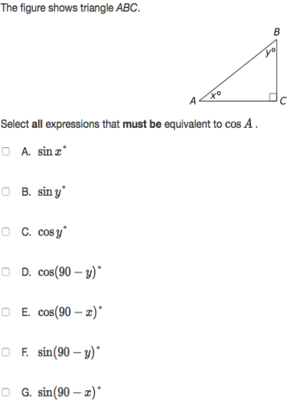
2. 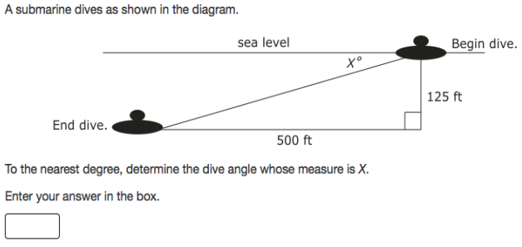
3. 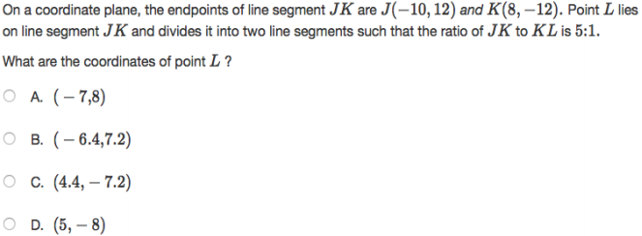

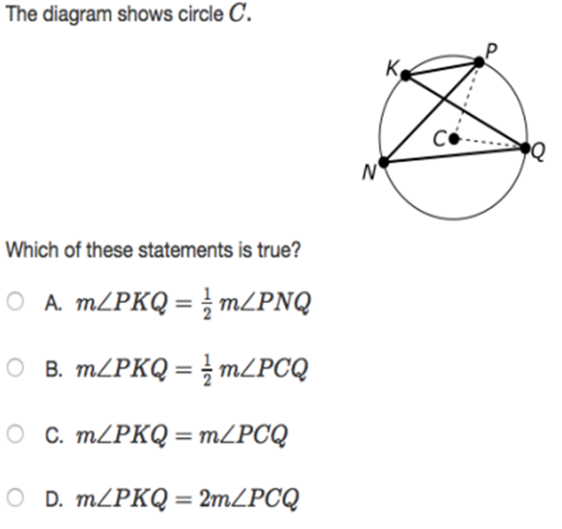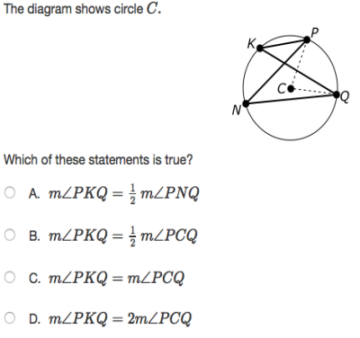

1. 
2. 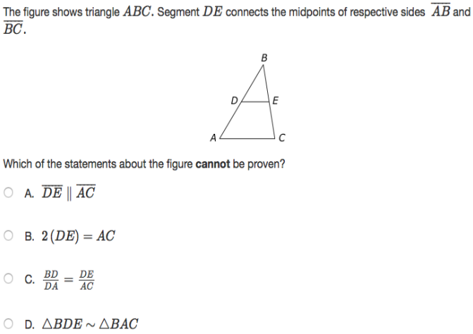
3. 