Name: _______________________________________________ Date: ______________

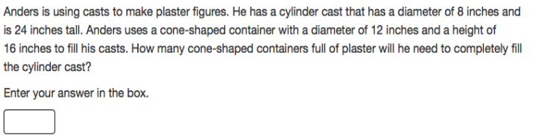PARRC Practice Volume

2. 