Name: ___________________________________________________ Date: ______________
Partitioning with Directed Line Segments
- Line segment LM has endpoints with coordinates L (-12, 10) and M (6, -8). Find the coordinates of the points that would divide 𝐿𝑀̅̅̅̅ into two parts with lengths in a ratio of 2:7.

- Find the point on the directed segment from (−4, 5) to (12, 13) that divides it into a ratio of 2: 5.

- Line segment RS in the coordinate plane has endpoints with coordinates R (7, -11) and S (-9, 13). Find two possible locations for point P that divides 𝑅𝑆̅̅̅̅ into two parts with lengths in a ratio of 1:5.

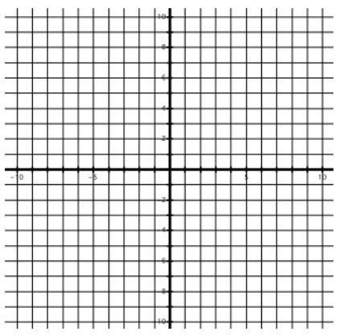
- Line segment AB in the coordinate plane has endpoints with coordinates A (3, -10) and B (-6, -1).
a) Graph 𝐴𝐵̅̅̅̅

b) Find the coordinates of point C that divides 𝐴𝐵̅̅̅̅ into 2 parts with lengths in a ratio of 1:2. Plot point C.

- Line segment JK has endpoints with coordinates J (11, 11) and K (-10, -2). Find two possible locations for point P that divides $\overline{JK}$ into two parts with lengths in a ratio of 2:5.

- What are the coordinates of the points that would divide the segment with endpoints from points P1 (2, 8) and P2 (7, 3) into two segments with the ration of 4:1?

- Find the point on the directed segment from (-2, 0) to (5, 8) that divides it in the ratio of 1:3.

- Line segment EF in the coordinate plane has endpoints with coordinates E (-10, 11) and F (5, -9).
a) Graph ̅𝐸𝐹̅̅̅

b) Find the coordinates of point G that divides ̅𝐸𝐹̅̅̅ into 2 parts with lengths in a ratio of 2:3. Plot point G.

