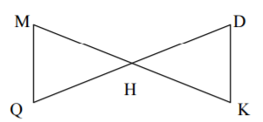  Given: H is the midpoint of $\overline{QD}$  $∠M≅∠K$  Prove: $∆MHQ≅∆KHD$ | Given: $\overline{GK}≅\overline{ML}$  $∠GKM≅∠LMK$  Prove: $∠G≅∠L$  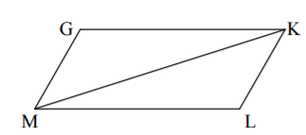 | Given: $∠STX≅∠RTX$  $\overline{XT}$ is the median of $∆SXR$  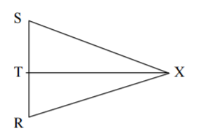  Prove: $∆STX≅∆RTX$
Given: $\overline{FT}≅\overline{FR}$  $\overline{ST}≅\overline{SR}$  Prove: $∆FTS≅∆FRS$ | Given: $\overline{BR}$ bisects $\overline{EV}$  $\overline{EV}$ bisects $\overline{BR}$  Prove: $∆BAE ≅ ∆RAV$ | Given: O is the midpoint of$\overline{NQ}$  $∠M≅∠P$  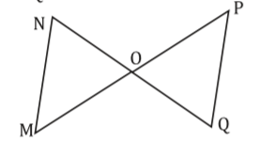  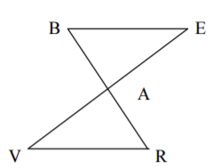  Prove: $∠N≅∠Q$
Given: $\overline{BC}$ bisects $\overline{AD}$  $∠A≅∠D$  Prove: $\overline{AB}≅\overline{DC}$ | Given: $\overline{PR}$ is the median of $∆SPR$  $\overline{SP}≅\overline{SR}$  Prove: $∆PSQ≅∆RSQ$ | Given: $∠1≅∠2$  $∠Q≅∠S$  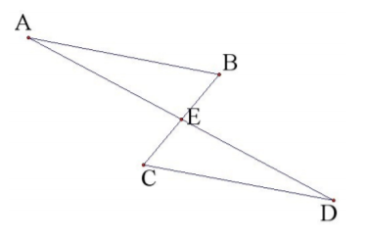  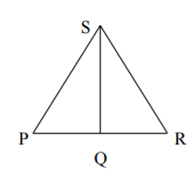  Prove: $\overline{RQ}≅\overline{RS}$  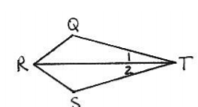
Tic-Tac-Toe Proofs
Directions: Complete any three proofs to form Tic-Tac-Toe!
Write your proofs on a separate sheet of paper and staple together before turning in.
- Given: $\overline{JG}$ is a perpendicular bisector of $∆FJH$
Prove: $∆FGJ≅∆HGJ$
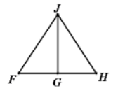

- Given: $∠K≅∠M$
$\overline{JL}$ bisects $∠KJM$
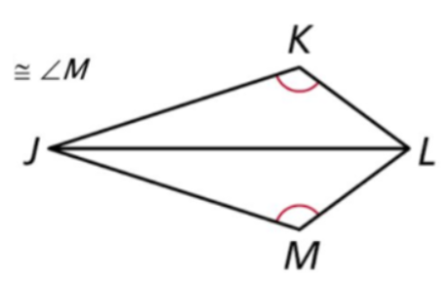
Prove: $∠KLJ≅∠MLJ$

- Given: $∠JGF≅∠JGH$
$\overline{JG}$ bisects $∠FJH$

Prove: $∆FGJ≅∆HGJ$

- Given: $\overline{CD}$ is a perpendicular bisector of $\overline{AB}$
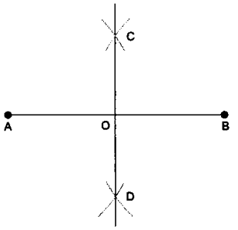
Prove: $\overline{AC}≅\overline{BC}$

