What are Proteins?

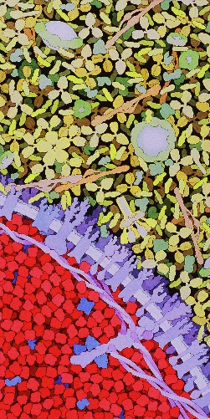
Proteins are the workhorses of our bodies
Proteins make up about 42% of the dry weight of our bodies. The protein collagen—which holds our skin, tendons, muscles, and bones together—makes up about a quarter of the body's total protein.
All of our cells and even blood are packed with protein molecules. This watercolor painting by David S. Goodsell shows part of a red blood cell, at the bottom left, filled with hemoglobin molecules. The upper half of the painting shows blood serum, containing yellow, Y-shaped antibodies and other proteins. In purple, proteins poke through the blood cell's membrane.

Proteins are versatile
A protein's three-dimensional shape is uniquely suited to its function. The 20-different amino acid, which are the building blocks that can be arranged in different ways to form a nearly infinite assortment of protein shapes.

Different arrangements of amino acids can make proteins that are extremely strong, as in silk fibers, or flexible and elastic, as in the elastin in our skin. And like pieces of a jigsaw puzzle, proteins can interlock with other molecules. For example, each type of antibody in our blood has a unique arrangement of amino acids at its tips that can attach to a specific pathogen, marking it for destruction by the immune system.

Proteins work together
Proteins need to physically interact with each other and with other molecules to do their work. These interactions might activate an enzyme, turn on a gene, or communicate a message from one cell to another.
Interactions between proteins depend not just on their shape but also on their chemical properties: positively and negatively charged amino acids are attracted to each other; hydrophobic residues cluster together, away from water. These physical properties allow proteins to interact in specific ways.

Proteins change shape
Cells are alive with motion, much of it driven by proteins. Many proteins are flexible and dynamic. Motor proteins, for example, bend and swing to literally walk across the cell's cytoskeleton. And when the neurotransmitter acetylcholine binds to its receptor, the entire protein molecule shifts, causing a hole to open up at its center. Sodium ions pass through the opening, starting a chain reaction that will fire a nerve signal across the brain.

Proteins are recycled
Like us, plants and animals are made of proteins. When we eat them, we eat protein. High-protein foods such as beans, meat, fish, cheese, eggs, and nuts give us both energy and building blocks to grow and maintain a healthy body.
The proteins we eat are broken down into their individual amino acid building blocks. We reuse these amino acids to build new proteins.

Questions: Use the reading to answer the following

- What is the function of the protein called collagen?
- Proteins are made of building blocks called what?
- How many different amino acids are there?
- The interactions between proteins depend on what two factors?
- Humans, plants and animals are all made of what?
- How do we get our protein?
- What are some foods that are high in protein?

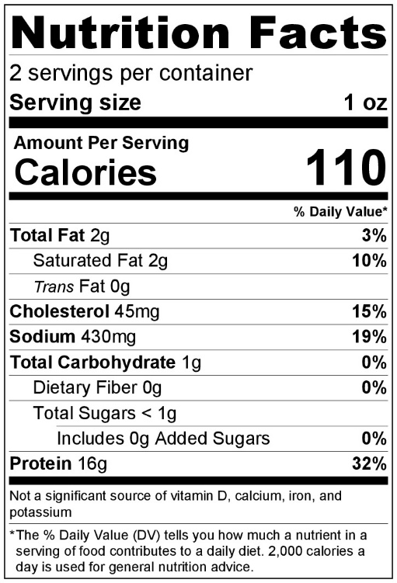
How do we know if our food contains protein?

The easiest way of determining if your food contains protein, is by simply checking the food label. Food companies are required by the FDA to provide a complete description of what can be found in your food. Protein is usually found towards the bottom and is described in grams. On the right, you can see the food label for a beef jerky packet, notice it contains 16 grams of proteins. It is suggested that the average adult should eat about 40-50 grams of protein per day. However, a lot of the time we find ourselves eating food that isn’t packaged by a company and are unable to tell if our food contains protein or not.

Although it’s impractical for everyday life, there are several scientific techniques that can be used to detect the presence of proteins in a solution. A quick and easy test is called a Biuret assay.

What is the Biuret Test for Proteins?

The Biuret assay or Test is often used to determine the presence of peptide bonds in protein. Today you will be testing for the presence of protein in foods using Biuret’s indicator solution. Biuret’s solution is a light blue solution that changes color to purple in the presence of protein (much like how iodine changes from orange to purple in the presence of starch). Follow your teacher’s directions and the procedure below to determine if different foods contain protein. Make your Pre-lab predictions before starting, complete your observation table while working, and answer the conclusion question when finished.

Pre-Lab Predictions

Your test tray will contain the following foods, predict if you believe each food has protein (Biurets solution turns purple) or no protein (Biuret’s solution stays light blue).

- Negative control - No Change / Purple
- Milk – No Change / Purple
- Sugar – No Change/ Purple
- Starch - No Change / Purple
- Egg White – No Change/ Purple
- Table Salt – No Change / Purple
- Beans – No Change / Purple
- Positive control - No change / Purple

Procedure
- Put on gloves and goggles. Keep these on throughout the entire activity.
- Receive a beaker of deionized water w/ plastic pipette, 8 plastic stir sticks, a Biuret’s dropper, and a white well tray from your teacher. The samples have been preloaded according to their labels found in the pre-lab.
- Add 10 drops of deionized water to each well.
- Stir the contents of each well to get the food into solution. Use a new stir rod for every well so you don’t cross contaminant your samples.
- Add 5 drops of Biuret’s solution to each well.
- Wait 5 minutes and record your observations below.

Observations
Well | Observations
A
B
C
D
E
F
G
H

Conclusions
Which foods contain protein? Explain how you know this using evidence from your observations. Can you tell if some foods have more proteins than others? If so, How?
____________________________________________________________________________________________________________________________________________________________________________________________________________________________________________________________________________________________________________________________________________________________________________________________________________________________________________________________________________________________________________________________________________________________________________________________________________

