Name: ______________________________________________________ Date: ________
Pythagorean Theorem and Converse Worksheet
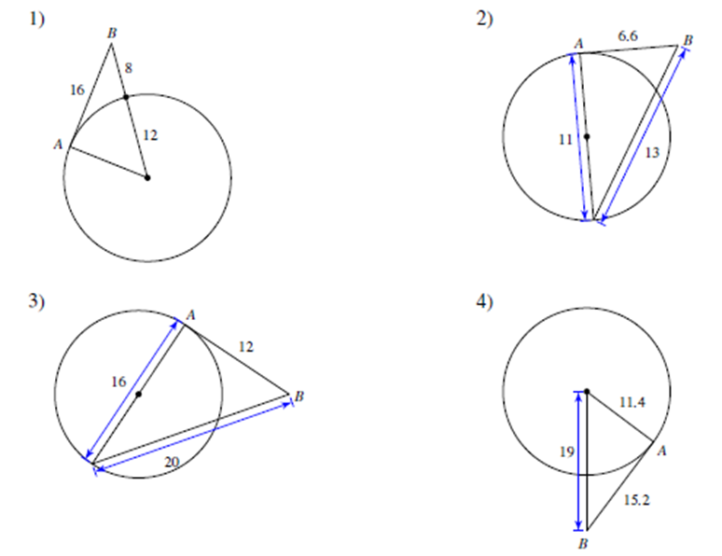
State whether the given line is tangent to the circle. Explain.

Name: ______________________________________________________ Date: ________
Pythagorean Theorem and Converse Worksheet
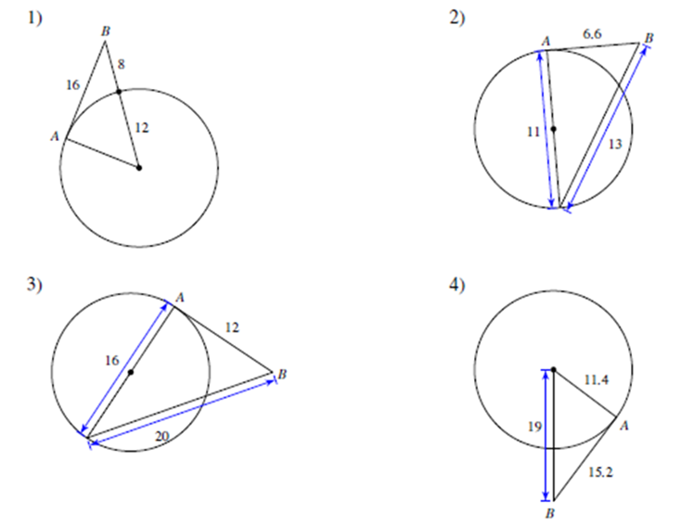
State whether the given line is tangent to the circle. Explain.

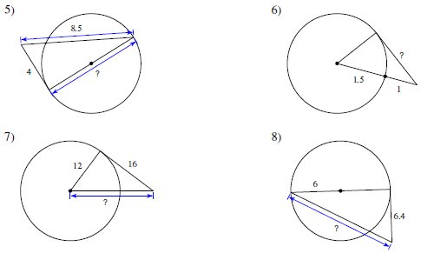
Given that the line drawn is tangent. Find the missing side measure.

Given that the line drawn is tangent. Find the missing side measure

