Name: _______________________________________________ Date: _____________________
Pythagorean Theorem & Converse
Warm-up: Is it a right triangle? Show your work.
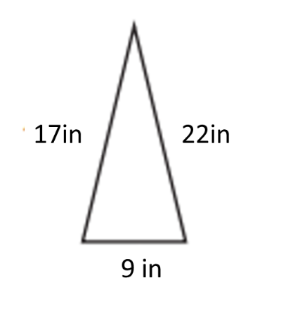

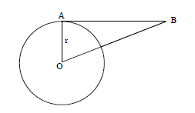
Is $\overline{AB}$ tangent to Circle O? Explain

1. 2.

3.

4. Point B is 29 feet from the center and 20 feet from Point A. Given that $\overline{AB}$ is tangent to the circle, find the radius.
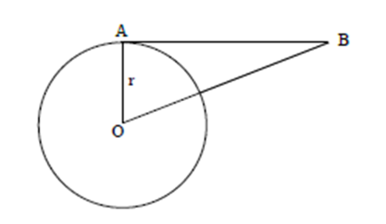

5. Point B is 25 feet from Point A and Point A is 32 feet from the center. Given that $\overline{AB}$ is tangent to the circle, find the distance between Point B and the center.

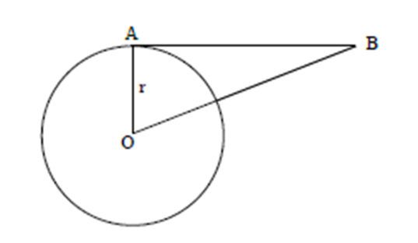
Exit Ticket:

