Instructions : Go around and interview your classmates. Find out who did the activities seen in the pictures, and note their names, with a couple of details about their vacation. Then, pick 2 or 3 of the pictures, and present to your class what those people did in their summer vacation.

1.  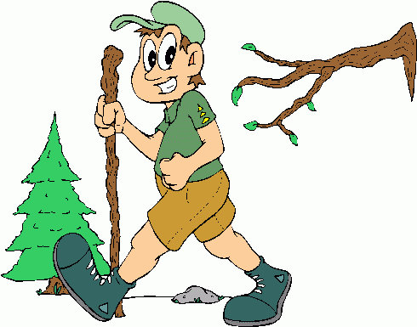  This Photo by Unknown Author is licensed under CC BY-NC-ND  ______________________________  ______________________________ | 2.  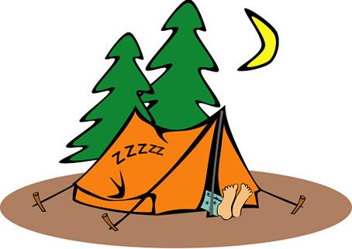  ______________________________  ______________________________ | 3.  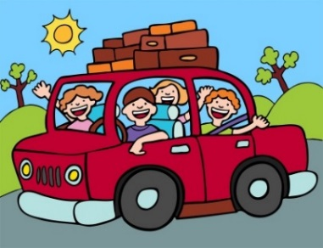  ____________________________  ____________________________
4.  ______________________________  This Photo by Unknown Author is licensed under CC BY-SA-NC  ______________________________ | 5.  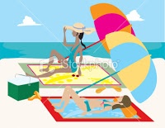  _____________________________  _____________________________ | 6.  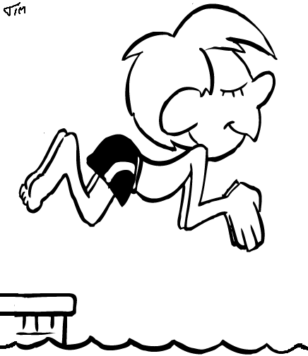  ____________________________  ____________________________
7.  ____________________________________________________________ | 8.  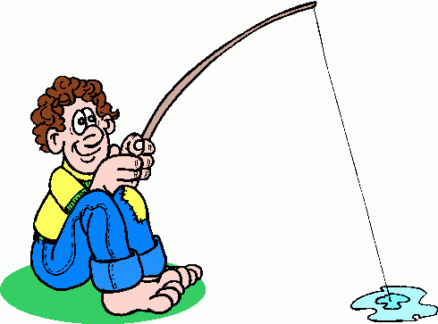  ______________________________  ______________________________ | 9.  This Photo by Unknown Author is licensed under CC BY-NC-ND  ____________________________  ____________________________

