Name: _____________________________________________ Date: ______________

Review: Unit 7 Quiz 2

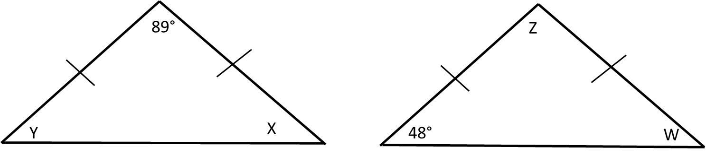Warm-Up:

Notes:

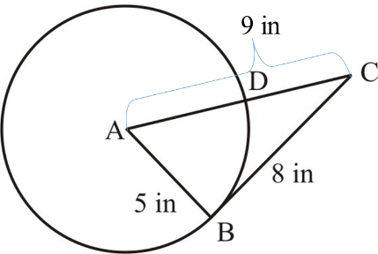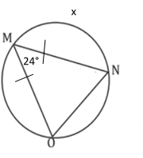

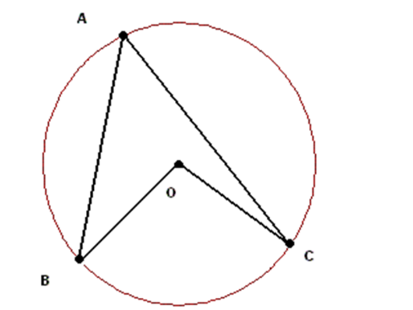

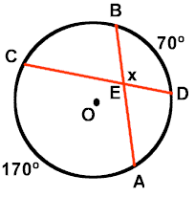

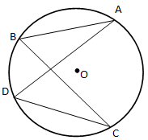

Central and Inscribed Angles Review: Find the value of x.

x

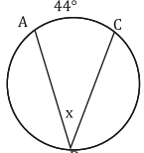

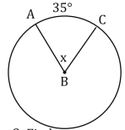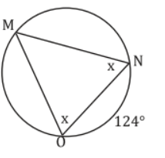

24°

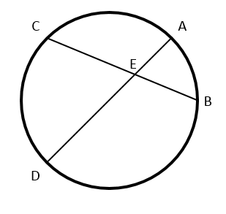

Vertical Angles Review: Find the missing measures:

$$\hat{AC}=76°$$

$$∠AEC=$$

$$∠DEB=$$

$$\hat{DB}=56°$$

Tangent Review:

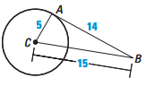Tell whether the line shown is tangent to the circle. Explain your reasoning.

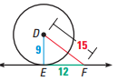

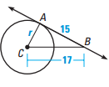Given AB is tangent to circle c. Find the value of r.

