RECALL (slopes and y-intercepts)
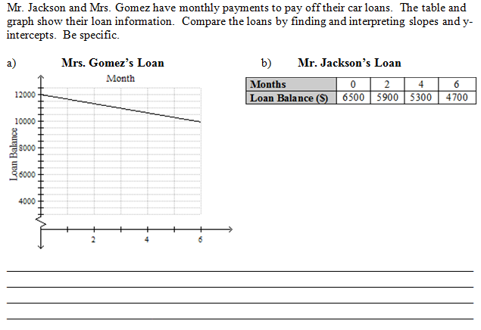

APPLY TO NEW
SLOPE a.k.a. GIVEN A TABLE
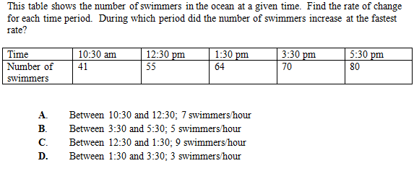

SLOPE a.k.a. GIVEN A GRAPH
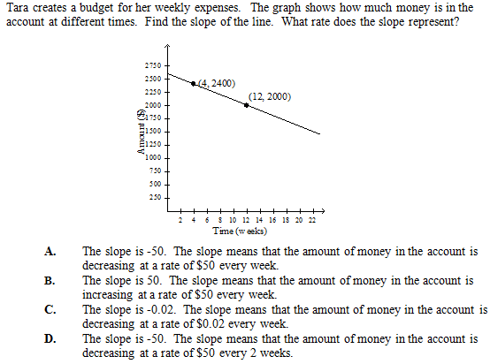
EXIT TICKET: Joe and Lena have monthly payments to pay off their college loans. The table and graph show their loan information. Compare the loans by finding their rate of change and initial values. Be specific.
Joe’s Loan Lena’s Loan
Years | 0 | 1 | 1 | 3
Loan Balance ($) | 30,000 | 26,000 | 22,000 | 18,000
