Cask of Amontillado
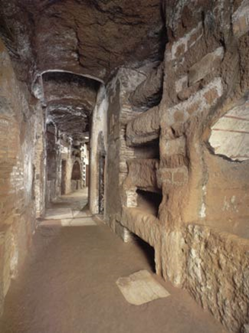
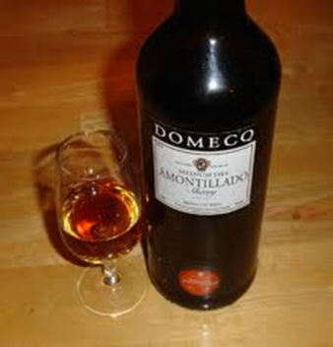
Words to Know:
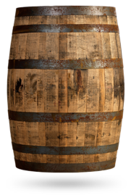
Amontillado Cask Catacombs
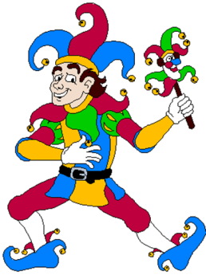
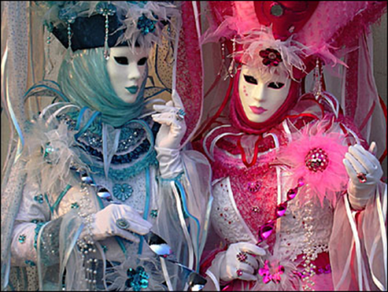

Carnival Motley

Summaries to get you started:
Paragraph 1 | I endured all the irritations of Fortunato until he started insulting me; then, I vowed revenge. You know me as a man who would never threaten Fortunato to his face, but I knew I would get my revenge. I was so sure of myself that I didn’t even consider the risk. All I knew was that I had to get even without getting caught. An insult is only forgotten when the insulter is punished and made to feel just as bad (eye for an eye).
Paragraph 2 | I did tell or show Fortunato that I was mad; he still believed we were friends. I smiled knowing he had no idea what was coming.
Paragraph 3 | Fortunato had one weakness—his love of fine wine. He was an expert when it came to wine. I was also skilled in old wines as well.

Helpful Notes:
Characters: Narrator (wants revenge) and Fortunato (drunk, wine lover)
Setting: Carnival festivities and the catacombs beneath the narrator’s house

