Name: _____________________________________________________ Date: ______________
Recognizing Series Worksheet
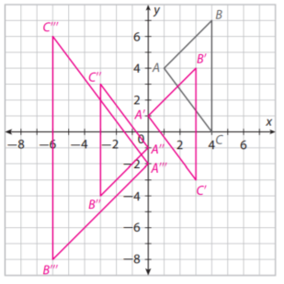
- State the series of transformations that occurred in order, include each rule.

- State the series of transformations that occurred in order. Include each rule.
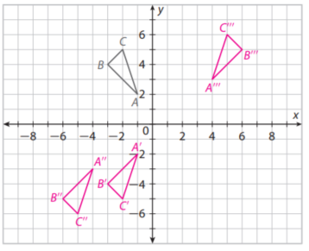

3. Perform the following series of transformations.
Translate △LMN $\left(x,y\right)→(x-2,y+3$, reflect across the line $x=0$, and then reflect across the x-axis.
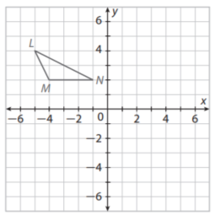

4. Perform the following series of transformations.
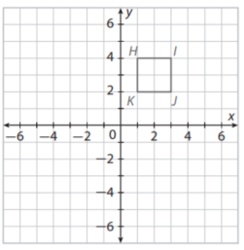
Rotate Square HIJK 90° clockwise about the origin and then dilate by a factor of 2.

5. For the following, write out what you think the sentence means in your own words and write which transformations you think it is true for.
- The distance between points on the polygon is preserved by the transformation.

- The orientation of points on the polygon is preserved by the transformation.

- The distance between corresponding points in the image and preimage is constant.

- The angle measures between sides on the polygon are preserved by the transformation.

