1. 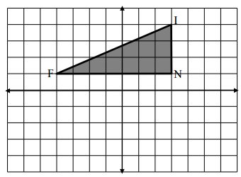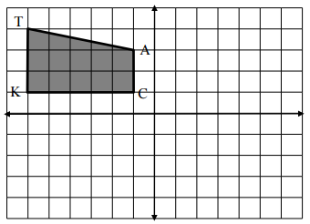Rule: __________________________ 4. Rule: __________________________
2. Rule: __________________________ 5. Rule: __________________________



1. Rule: __________________________ 6. Rule: __________________________

