Name: _________________________________________________ Date: _____________________
Reflections Worksheet
In each problem, a figure and its image are shown. Identify the type of transformation, and then the rule. If it is a reflection, you must also draw in the line of reflection.

1. Transformation: _______________________ 2. Transformation: _______________________
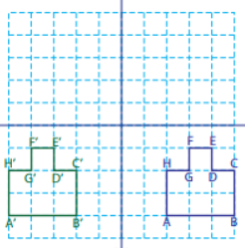
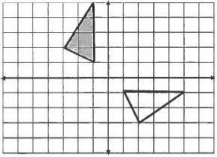
Rule: ________________________________ Rule: ________________________________
A
B
C
A’
B’
C’

3. Transformation: _______________________ 4. Transformation: _______________________
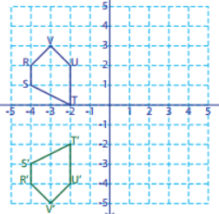
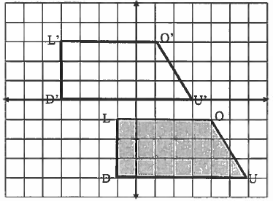
Rule: ________________________________ Rule: ________________________________

5. Transformation: _______________________ 6. Transformation: _______________________
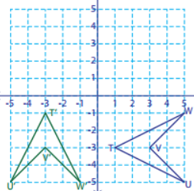
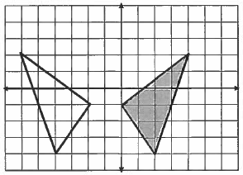
Rule: ________________________________ Rule: ________________________________
L
L’
U’
U
V
V’

In each of the following, apply the given transformation to the figure. Be sure to label all points.
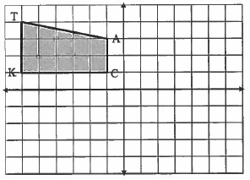
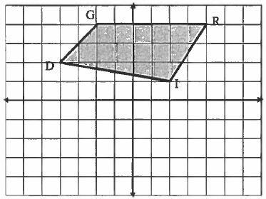
7. $(x,y)→(x-2, y-5)$ 8. Reflect across $y=x$

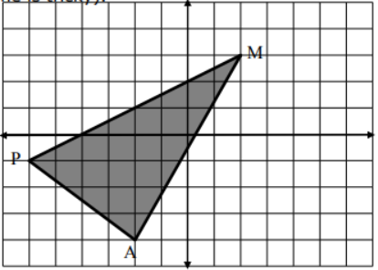
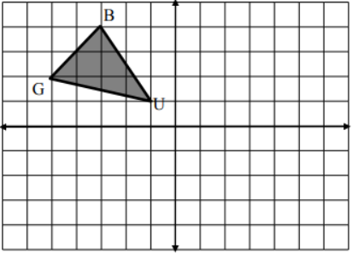
9. Reflect across $y=-1$ 10. Rotate 270° counter-clockwise

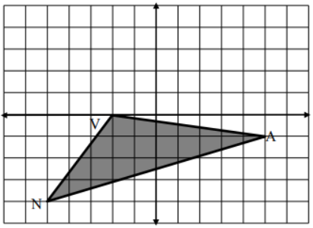
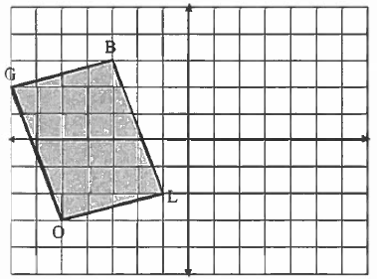
11. $\left(x,y\right)→(x+8,y)$ 12. Reflect across $x=1$

13. Write the congruency statements for problem #11 (there should be four pairs of sides and four pairs of angles)

