Name: ________________________________________________ Date: ______________
Right Triangle Trigonometric Functions & Inverses Worksheet
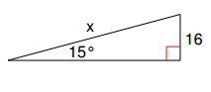
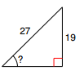
1. 2.

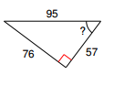
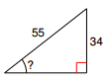
3. 4.

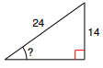
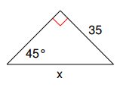
5. 6.

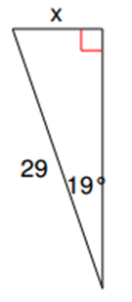
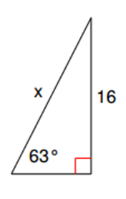
7. 8.

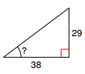
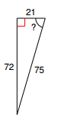

9. 10.

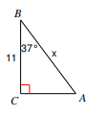
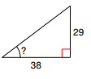
11. 12.

